**RESUME**

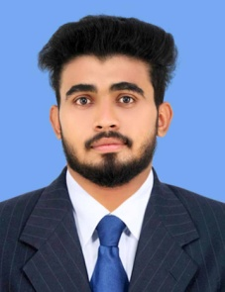

# **EBRAHIMKHALEEL.SAP**

Address: SAP HOUSE Mobile- + 91 8592056002

MUTTOM Email: ebrahimkhaleelsap@gmail.com

VENGARA(P.O)

Kannur (District)

Kerala, india

PIN:670305

# **Career Objective**

To secure a position where my hard work, dedication and the ability to acquire new skills will advantage the organization I work for. I want to be a part of an organization that can provide me the opportunity to fulfill my sincere desire to augment my insight into my field of interest, gaining a substantial amount of experience.

# **Software Proficiency**

Operating System : DOS, Windows XP/Vista/ Win7, 8, 10 , linux

Software Skills : MS Office, Adobe Photoshop,java,.net,c,cpp,HTML

PHP,SQL

Technical skills : troubleshooting, cctv , networking ­

# **Academic Qualifications**

* **SSLC**
  + - **PLUS2 (COMEMERCE)**
* **BACHLOR OF COMPUTER APPLICATION (BCA)**
* **DIPLOMA IN SYSTEM ENGINEERING**

# **Work Experience**

* Worked as Cashier with V-pra Kayal Floating Park for the period of 1 year.
* Worked as it support with safa English medium school for the period of 2 months
* Worked as sales exicutive with idealdecor furniture for the period of 1 year.

# **Personal Information**

* Name : EBRAHIMKHALEEL.SAP
* Date of Birth : 30/06/1997
* Gender : Male
* Nationality : Indian
* Passport No. : R 0779885
* Languages Known : English, Malayalam,hindi

I hereby declare that the information furnished above is true to the best of my knowledge and belief.

EBRAHIMKHALEEL.SAP