CURRICULUM VITAE

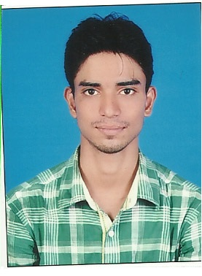 Paste  Photo here  ZAFAR IQBAL  MBA (Marketing & HR).  email: iqbal.zafar738@gmail.com  Mob : +971544687277  Present Address  OLD JARONI BUILDING.  NEAR AL HAYAT HOTEL.  AREA :- MAHATTA SHARJAH.  UAE.  Permanent Address  S/o Iqbal Ahmad Manzer ,PO+PS-Buniyadganj  Distt. Gaya  Pin Code: 823003  State : Bihar, INDIA  Personal Details  Father’s name:-Iqbal Ahmad Manzer  Mother’s name: Nusrin Bano  Date of Birth: 09th january, 1993  Sex : Male  Nationality: Indian  Marital Status : Unmarried  Language :English,Hindi & Urdu | Objective  To join a progressive organization for enhancement of professional skill to benefit the organization by utilizing it up to optimum level.  Education  Master In Business Administration with Specialization Marketing & HR  Work Experience  Worked as a sales Executive for 3 and half yrs till now in ETISALAT  Work Responsibility  .  - To raise Fund.  - Lead generation.  - And Meetings.  Educational Qualification :  Qualification Name of Institution University Year of Passing Marks Obtained  MBA K.C. COLLEGE OF ENGineering & IT PTU 2015 73%  BBM MIRZA GHALIB COLLEGE MU 2013 65%  ISC HADI HASHMI MU 2010 60%  Matriculation G.B.P.S CBSE 2008 50%  Computer Skill MS Office, Internet,Tally.  Major Project, IN MBA  Project Title Sales Promotion of TATA Motors  Project Details and Objective To provide ideas and ways of Sales Promotion.  Strengths:  - Self Motivated  - Good communication skills  - Quick learning skills  - Ability to work under pressure  - Amiable in Nature  Hobbies:  - Playing Cricket.  - Chatting with Friends.
I hereby declare that above-mentioned details are true and best of my knowledge.

Zafar Iqbal
SHARJAH.

