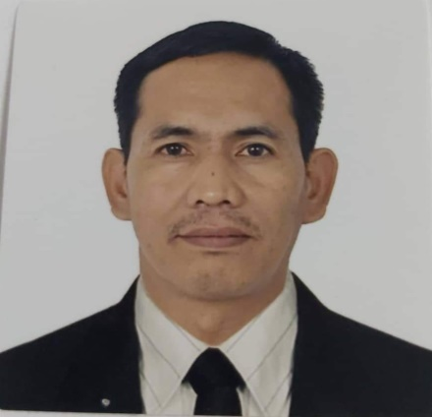

**JONATHAN ANOBA MORALES**

BUILDING PAINTER

WORK EXPERIENCE ABROAD WORK EXPERIENCE LOCAL

6 YEARS 8 YEARS

OBJECTIVE

I’m seeking for company where my experience can not only improve the status of the company but also automate the working process to the best possible one.

**WORK EXPERIENCE**

Company Name : **MAD Cornstruction Services**

Position : ***Building Painter***

Location : Hermosa Bataan, Philippines

Duration : September 6, 2000 – March 22, 2007

Project : Camella

Company Name : **OGER ABU DHABI**

Position : ***Building Painter***

Location : Al Ain, United Arab Emirates

Duration : November 26, 2007 – July 7, 2010

Project : Al Ain University

Company Name : **TAV CONSTRUCTION**

Position : ***Building Painter***

Location : Doha, Qatar

Duration : July 07, 2011 – November 15, 2014

Project : New Doha International Airport Project

Company Name : **TAV CONSTRUCTION**

Position : ***Building Painter***

Location : Riyadh Kingdom of Saudi Arabia

Duration : May 22, 2015 – April 30, 2017

Project : King Khalid International Airport Terminal 5

Company Name : **ARABTEC LLC**

Position : ***Building Painter***

Location : Abu Dhabi, United Arab Emirates

Duration : October 20, 2018 up to present

Project : Abu Dhabi Airport

**DUTIES AND RESPONSIBILITIES**

* Directly report to the supervisor and project manager in connection with all necessary jobs.
* Cleaning and preparing surfaces.
* Mixing plaster ingredients.
* Applying, levelling and smoothing coats of plaster.
* Finishing corners and angles and creating decorative designs.
* Spraying finish over walls and ceilings.
* Filling joints, holes and cracks with compound using trowel and board knife.
* Smoothing out excess compound and sanding over dry compound.
* Reviewing the data sheets of any brand of paint prior to client’s requirements.
* Cleans and prepare surface for painting.
* Accurate knowledge in painting mixing.
* Selects paint according to company colour scheme and specifications

**POWER TOOLS**

* Hand Drill
* Sanding Machine

**HAND TOOLS**

Trowels Paint Tray/Paint roller

Hand Gloves Ladder

Spatula Jointing Knife/Taping Knife

Flash light

Spirit Level

Tape

**PERSONAL INFORMATION**

Age : 44 years old

Date of Birth : April 26, 1975

Place of Birth : Dinalupihan, Bataan

Civil Status : Married

Gender : Male

Height : 5’9”

Weight : 83 kg.

Citizenship : Filipino

Driving License : C02-17-001249 / Restrictions: 1 & 2

Contact Number : +971-563949537

**EDUCATION ATTAINMENT**

Secondary Level : **Northern Bataan Institute**

Elementary : **Paggalangang Elementary School**

***TRAINING’S***

* Occupational Safety and Health Training
* Basic Scaffolding Training

**CHARACTER REFERENCES**

Selami Esirti Foreman

TAV Construction

Abu Dhabi, UAE

+971-563191545, +971-565714848

Byron Velasco Site Engineer TAJV

Abu Dhabi, UAE

[engnrby@yahoo.com](mailto:engnrby@yahoo.com)

+971-543325045

Siddik Foreman

TAJV

+971-556442638

Roy Roger Punay Site Engineer

Camella

Pampanga, Philippines

royrogerpunay@camella.com.ph

+639-338695488 / +639-566193347

*I hereby certify that the above information is true and correct to the best of my knowledge, belief and ability.*

**JONATHAN ANOBA MORALES**

Applicant