**Objectives: 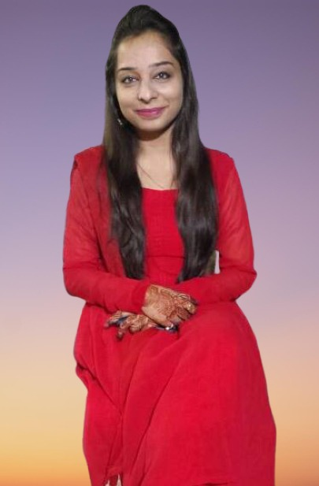**I am a self-motivated and focused person who believes in goal orientation and achievement through dedication. My intention is to use my skills and knowledge to conceive, develop and implement programs that significantly impact the enterprise I am associated with. A Highly Professional and dedicated dietician with over 3years of experience in constructing meal plans,and helping people eat healthier and reach their goals.

Experienced in training and mentoring new members of staff.

**Highlights:**

Adept at accomplishing multiple tasks and simultaneously working under pressure. Hard Working & Career Oriented. Quick Learner, Analytical ability , High degree of initiative, self-motivation and ability to motivate others

Food counseling**,** dietary habit expert, Body composition Analysis, Weight management counseling, Problem solving, good listener,Positive and focused

Strong skills in using **Social Media Activities** such as Google Plus, Face book, Instagram, LinkedIn, and Outlook.

**WORK HISTORY**

**COMMUNITY DIETICIAN @ Lifetime fitness Gym**

**Duration of service: 2017 to 2020**

* + Interviewed clients to analyze dietary habits and overall health concerns.
  + Established and maintained thorough nutritional records and information.
  + Instructed clients in proper meal preparations and diet therapies.
  + Planned, directed and monitored the appropriate functions of the dietary department.
  + Educated clients about the long term health benefits of balance diet and exercise programs.
  + Preparing Diet Charts for the clients and maintaining proper check on day to day basis.
  + Maintaining Proper data of all the clients and giving them proper health advisory.

**EDUCATION**

|  |  |  |  |  |
| --- | --- | --- | --- | --- |
| **Standards/Course** | **Institute** | **Grades** | **Year of Completion** | **Major** |
| Bachelor in Food & Nutrition | Maharaja Sayajirao University | B | 2014 | food science & quality control |
| H.S.C Board | Zenith High School | 59% | 2011 | Commerce |
| S.S.C Board | Zenith High School | 58% | 2009 | - |

**Area of Interests:**

Besides shaping the human meal plans, I do take interest in shaping the canvas with colors, craving the stones with clay, and a lot more handmade crafts.