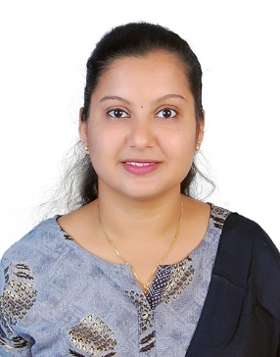**Curriculum Vitae**

**Alveera Glenisha Fernandes**

Contact and Address:

9480469010

[alveeragfernandes@gmail.com](mailto:alveeragfernandes@gmail.com)

**Objective**

A self-Motivated, hardworking and dedicated towards the work assigned. I aspire for a challenging position in a professional organization where I can enhance my professional skills and strengthen my performance in adding with organizational objective.

**Education**

**Master of Business Administration (MBA)** Visvesvaraya Technological University- 69.8% (2017-2019)

Major- Finance and Marketing

**Bachelor or Commerce (B.com)** Mangalore University- 75.8% (2017-2019)

Major-Taxation

**Work Experience**

**London Stock Exchange Group**

Bangalore

Associate Content Analyst (January 2021- January -2022)

* Process and maintain Data/ information accurately and in a timely Manner into the data base using financial and technical knowledge.
* Respond to data Queries from both Internal and External Clients.
* Research new and Review Existing Sources for Improvement.
* Test new Database/ application release for Expert User Feedback.
* Support Specific Projects and Data Enhancements.
* Research and respond quickly to client issues, adhering to quality goals for accuracy and Timeliness.

**Muthoot Group**

Bangalore

Assistant Manager (August 2018- January 2021)

* Preparations and Analysis of Monthly Target vs Achievement.
* Preparation of Weekly and Daily MIS of the personal Loan leads.
* Coordinating with Internal Sales Agents and the Clients.
* Preparation and Submission of Sales Reports to the Clients.

**Projects**

**Karnataka State Council for Science and Technology (KSCST):**

* Prepared a project report on ‘‘Biogas and Organic Vegetables- financially feasible Agri Business project with Special reference DEDS Scheme of NABARD.

**Academic Project- Share Khan Limited**

* Prepared a Project Report - To understand the impact of raw material prices on the top 5 listed Tyre manufacturing companies in India.

**Academic Project - United Breweries**

* Conducted organization study to understand the organizational Culture and Activities.

**Achievements**

* Secured first place in the case study competition in Strategic Management on the case Hindustan Unilever ltd. Organized by Mangalore Institute of Technology and Engineering.
* Presented National level paper which was held at St. Joseph Engineering college, Vamanjoor on the topic “Effect pf sales promotion on consumer buying behavior”.
* Attended 7 days National Social Service Camp
* Participated in NCC combined annual training camp.

**General Skills**

* Microsoft Office Word, Microsoft Office Excel, Microsoft Office PowerPoint.
* Leadership, Relationship Management, Goal Oriented.

**Language**

* English
* Kannada
* Hindi

**Passport Details**

* Passport No: P8590239
* Place of Issue: Bangalore
* Date of Expiry: 15/03/2027

**Declaration**

I hereby declare that the information furnished above is true to the best of my knowledge.