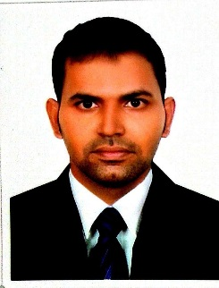

**ABDUL RAHMAN MUTTARIF**

Mobile; +917619661044

Email; abdulmutarrif@gmail.com

**Career Objective**

*Seeking a suitable position in accordance with my work experience and skills gained over the years to the full extends for development, thereby contributing to the overall growth and profitability of the organization as well as attaining self-growth in career.*

**Personal Profile**

* Having 4 Years of work experience in Retail Sales.
* Focused with personalized service for client satisfaction, hardworking and optimistic attitude towards goals and friendly nature.
* Good communication skills in English, Hindi / Urdu.

**Work Experience**

**Company : SHAIKH MOHD SAEED GROUP OF COMPANIES (AL HUNAIDI PERFUMES)Dubai**

**Period : From August 2016 to July 2020.**

**Position : Sales Executive**.

**My Duties and Responsibilities Include Is.**

* Maintaining and increasing sale of our company’s product.
* Reaching the targets and goal set by company.
* Servicing the needs of our existing customers.
* Handle customer complaints, questions and issues.
* Monitor local competitors.
* Organize sales staff schedules.
* Ensure promotions are in with company’s standards.
* Developing sales strategies and setting target.

**Work Experience**

**Company : Hamidia hostel mumbai**

**Period : From January 2012 to December 2014 (2Years)**

**Position : Office in Charge**

**Educational Qualification**

* **B.Com : Bachelor of Commerce (Dharwad University ,India)**
* **CIA : Certified Industrial Accounts (Mumbai, India)**

**Computer Skill**

* **MSOffice (Ms Word, Ms Power point, Ms Excel).**
* **Tally ERP9; can be adapt any update version.**
* **Expert in Web Browsing, Multimedia, Social Me.**

**Personal Information**

Date of Birth : 01/08/1988

Nationality : Indian

Languages known : English, Hindi / Urdu/Arabic

Marital Status : Married

**Personal Strength**

* Ability to inspire and motivate others as well as to own initiative to display personal qualities such as reliability and efficiency.
* Good communication skills.
* Hard worker and team player.

**Declaration**

I hereby declare that the information has been given above is correct and to the best of my knowledge.