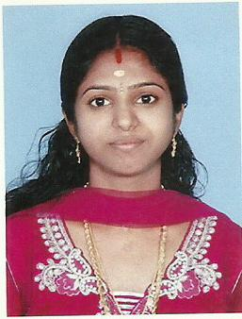
Anusree k

Phone: 8086763578
Email: anuprayag2012@gmail.com
.

Education

MBA Information System Management in Bharathiar University 2015

BSc Information Technology in AJK College of Arts and Science 2011

Plus Two Board of Higher Secondary Kerala 2008

SSLC Board of Examination Kerala 2006

Awards

Global Warming National Seminar 2008

Experience
Tele Marketing Staff in First Source Solutions 2012

Office Assistant in Kerala Milk Federation 2014

Sales and Marketing Intern in IFORTIS World 2021

Technical qualifications

- Tally
- Microsoft Office
- Microsoft Excel
- Programming Language - C,C++,VB
- Data Base - SQL
- Strong Knowledge on Internet

Personal Profile

Date of Birth 23-01-1991
Gender Female
Nationality Indian
Marital Status Married
Passport No L5483564

Languages

Malayalam - Native Language
English - Reading, Writing, Speaking
Tamil - Speaking
Hindi - Reading, Writing , Speaking
Sanskrit - Reading, Writing , Speaking

Personal Information

Husband’s Name Sinosh
Father’s Name Kittumani
Mother’s Name Jyothi
Religion Hindu
Hobbies Reading
Books

Declaration:
I hereby declare that all the information stated above is true and sincere to my knowledge

Place: Palakkad ANUSREE K
Date:

