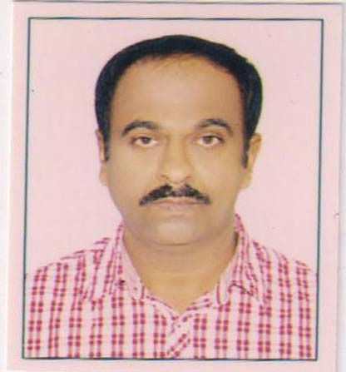

CURRICULUM VITAE

JOSEKUTTY
Dubai PH: 0555440706
INDIA 0091 8085771690
Email ID : joseplr1970@gmail.com

OBJECTIVES
Having identified my potential, I would like to the growth of an organization, which is able to utilizes my dynamic experience and creative skills while offering me a challenging position and a promising career growth.

POST APPLIED FOR : MACHINIST (LATHE MACHINE, MILLING, BORING SHAPING AND RADIAL DRILLING MACHINE, VERTICAL BORING

PERSONAL DETAILS :-
- Father's Name : Kuruvila
- Date of Birth : 22.05.1968
- Gender : Male
- Marital Status : Married
- Nationality : Indian
- Permanent Address : Valumannil Veedu,
Manalil P.O, Karavaloor
Kollam Dist.
Kerala, India
- Educational Details : S.S.L.C passed
- Languages Known : English, Hindi & Malayalam

PASSPORT DETAILS
Passport No. : T 8142588
Date of Issue : 05 -08 -2019
Date of Expiry : 04 -08 2029
Place of Issue : Trivandrum

PROFESSIONAL WORK EXPERIENCE
Presently working as a Machinist in Grant weld ship yard Dubai maritime city (DMC) Dubai
Worked as a Machinist in Al Nasser engineering Ghusais, Dubai from 03/03/2019 to 23/03/2021.
* worked as a machinist in inter ocean ship repair Dubai maritime city from10- 10-2016 to15-03-2018
- Worked as a Machinist in Fabtech International Ltd, Jabel Ali Free Zone, Dubai -UAE since October 2010 to 2016 August.
- Worked as a Machinist in KNPC -MAA Project at M/s. ISCO /KNPC, Kuwait from Jan-2009 to May -2009.
- Worked as a Machinist in Ara Eagle Marine Engineering, Dubai from 1995 to 2007.
- Worked as a Trainee Machinist in Al Majeeb Engineering, Dubai from 1992 to 1995.
- Worked as a Turner I Vijay Engineering Mumbai - India from 1990 - 1992.

DECLARATION
I hereby declare that the details stated above are authentic at the best of my knowledge and belief.

JOSEKUTTY

