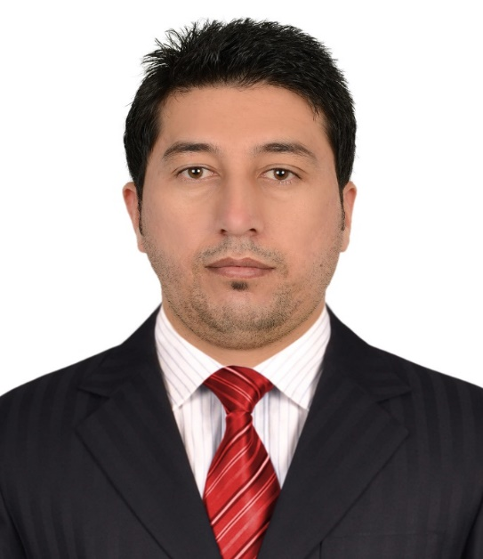Akbar Jan |  | EDUCATION
MBA (Master of Business Administration):
Islamia College university Peshawar Pakistan
2012—2014
16 years’ education

BSC (Bachelor of sciences):
UNIVERSITY OF PESHAWAR Pakistan
2010—2012
14 years of education

DIT (Diploma of information technology):
Additional Qualification
2011 (Duration 1 year)

PROFILE  I am seeking an employment in a competitive and challenging environment which provide me advancement opportunities, where I can use my education, experience and skills for organizational and personal growth.  CONTACT  PHONE:  +971 521832280  ADDRESS:  Alqouz/2, Dubai UAE  Email:  akbarkpk83@gmail.com  PERSONAL INFORMATION  Gender: Male  Nationality: Pakistani  Date of birth: July 1989  Marital status: Married  Religion: Islam  Visa status: Employment  Passport no: FK8795251 |  | WORK EXPERIENCE
FACILITY SUPERVISOR:
Location: Dubai UAE
May 2019 -to- Present.

Duties and Responsibilities:
- Supervising and coordinating the Day-to-day Maintenance, Cleaning, and Security tasks.

- Maintenance includes (Mechanical, Electrical, Plumbing, HVAC, Safety and Waste management)
- Security includes (IT system like CCTV and Access control, Emergency responses, Incident investigation, and all other standard security duties)
- Cleaning includes (supervision of the cleaning staff, ensuring that cleaning is delivering to all areas of the building and focusing on staff performance)

CUSTOMER SERVICE REPRESENTATIVE:
Location: Dubai UAE
August 2016 – January 2019.

Duties and Responsibilities:
- Answering incoming calls and responding customers queries via telephone, person, mails, and follow up customers calls where necessary.
- Helping customers by providing helpful information, always in a professional and efficient manner and ensure that customers are satisfied
- Keeping records of customers’ interactions, comments, complaints, and all call information according to standard operating procedure.
- Managing and dealing with cleaning and maintenance issues.
- Preparing daily work report about issues and problems to the site supervisor.

INTERSHIP:
(Location: Pakistan)
National Bank of Pakistan
For degree completion
Duration (06 Months)
Duties and Responsibilities:
- Worked at (Remittance Department, Cash Department).
- Managing transactions of customers using cash registers and collecting payments whether in cash or credit.
- Perform clerical tasks such as typing, filing and issuing receipts.
- Sort and file deposit slips and checks.
- Inform customers about foreign currency regulations, and compute transaction fees for currency exchanges.
- handling 40 to 50 transactions on average daily, and count money in cash drawers to ensure the amount is correct.

PROJECT SUPERVISOR:
(Location: Pakistan)
Haji Mirza Gull and Sons
Construction Company KPK Pakistan
2014 –To – 2016

COMPUTER OPERATOR:
(Location: Pakistan)
Daily Frontier News (News Paper) Peshawar Pakistan
May 2007 –To – Sep 2008

SKILLS

- MS Office (word, Excel, PowerPoint, Outlook).
- Typing and Ability to efficiently use of an advanced Software’s.
- Advance math’s skills
- Excellent interpersonal communication
- Ability to effectively manage time and prioritize tasks
- Strong product knowledge and understanding of target customers
- Professional telephone etiquette
- Ability to work in a busy environment.

Licenses:
- Problem solving.

- UAE Driving license/no, 03-Manual
- DPS, (Department of Protective System)
- SIRA, (Security Industry Regulatory Agency)
- Fire Fighting
- Safety First
- First Aid

Degree Attested Form
- POD (People of Determination

- UAE Embassy
- Foreign Office Pakistan
- HEC (Higher education Commission of Pakistan)

Languages

- Controller of University Board

- English
- Urdu
- Pashto
- Hindi

REFERENCE:
Will be providing on demand
____________________
AKBAR JAN (Applicant

