CURRICULUM VITAE

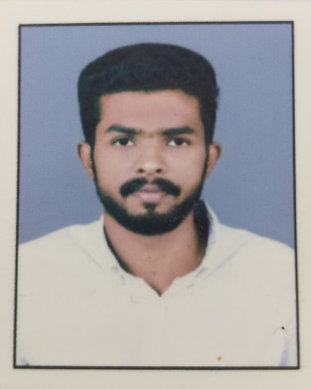
ARJUN VIJAYAN
KANJIRATHINGAL HOUSE
KAYANTIKKARA,
MUPPATHADAM P O
ALUVA-683110
Phone: +91 9544368158, 9388266264

Personal Details:

Date of Birth: 14-05-1996
Father’s Name: Vijayan K R
Religion: Hindu
Nationality: Indian
Marital Status: Single
Gender: Male
Languages Known: English, Malayalam & Hindi

Education

Qualification | Institution and  Board/University | Year of Passing | Percentage
S S L C | Kerala Board of Public Examination | 2012 | 65
Plus Two | H S E Kerala | 2014 | 70
B A English | M G University | 2017 | Course completed
Professional Diploma in Computerised Financial Accounting(PDCFA) | Kerala State Rutronix | 2019 | passed

Work Experience:

- Six month sales executive at Mobile Point, U C College, Aluva.
- 3 year relationship manager at indus nexa kalamassery

Hobbies:
- Reading, Travelling, Music and Gardening

General Skills:

- Excellent Communication and presentation skills.
- Highly Motivated and Target Oriented.
- Very much adaptable and flexible.

Declaration:
I here by declare that above mentioned details are true to the best of my knowledge and belief.

Place: Muppathadam
Date:
ARJUN VIJAYAN

