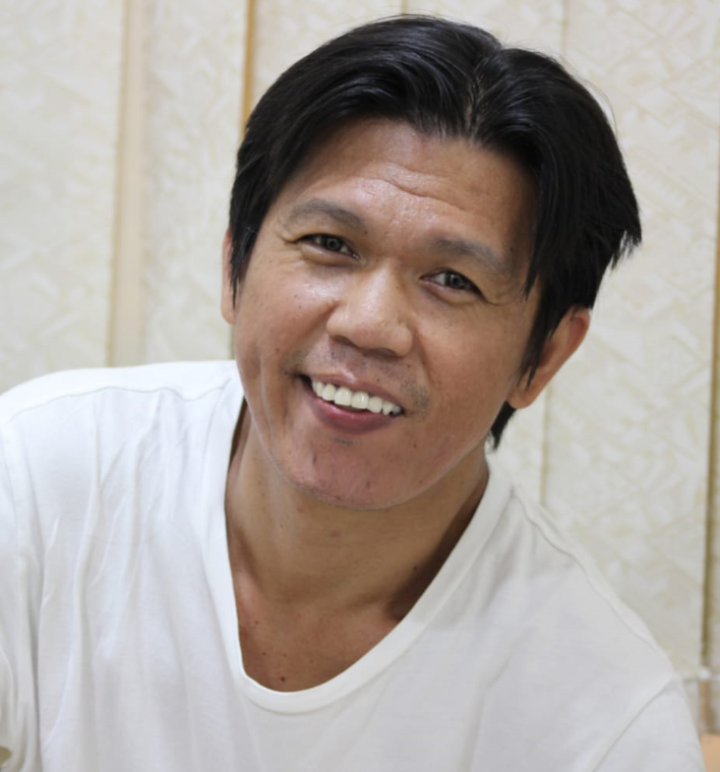**Rajib M. Sakandal**

Contact No: 0554519823

**Email**: [Rajib.sakandal@marriott.com](mailto:Rajib.sakandal@marriott.com) / [Rajib.sakandal@gmail.com](mailto:Rajib.sakandal@gmail.com)

**CAREER OBJECTIVE**:

To work in an organization where in, I can develop more my knowledge; seeking a Challenging opportunity for any position in a company where by my Experiences, education and abilities will be effectively utilized by the company and me.

WORKING EXPERIENCES:

HOUSEKEEPING DESK COORDINATOR

Le Royal Meridien Beach Resort + Spa

West Marina, Dubai U.A.E

June 2014 – Presents

* Answers all telephones, dispatches via 2-way communication system and generates computerized reports to ensure department compliance with service standards.
* Handle team member and guest requests by delegating to the appropriate individuals and Follow up to ensure department and hotel standards are met.
* Maintain the computerized Work Order System. This requires logging and recording all Service requests, implementation, distribution, and closing of all Work Orders.
* Ensure vacant/ready rooms are available to the Front Office through coordination with the Floor supervisor.
* Guest Supplies controlling, preparing the needed requisitions and handling lost and found.
* Presentation of a positive, professional, and courteous image, to insure guest satisfaction.
* Provide file in assistance in the absence of the Administrative Assistant or Storekeeper.
* Well knowledge in lost and found procedure (valuables and non-valuables item)
* Well knowledge about babysitting procedure & booking TNT / FedEx courier for posting the item.
* Knowledge in Housekeeping administrator. (Ace Financial, attendants tracking, vacations, ordering supplies, creating Hotel gate pass. Guest email lost and found, baby sitting and etc.)

HOUSEKEEPING ROOM ATTENDANT:

Grosvenor house Hotel, and hotel apartment

A Luxury Collection Hotel

West Marina, Dubai UAE

May 1st 2011 – June 2013

* Greeting the guest and always offer the further assistance, and make sure that we delivered to the guest the correct and right information of the hotel.
* Maintaining the cleanliness of the room (SOP) standard of performance of the hotel.
* Look after the room and belonging of the guest while they are staying with us.
* To make sure that we meet the guest expectation and the quest satisfaction.
* To ensure the guest happy, relaxing and enjoying their vacation, or any occasion while they are staying with us and giving them a relaxing experience and a memorable experiences that would be a remarkable moment to them.

COMPUTER OPERATOR:

Sanyo Factory Corporation,

Masai, Johor Bahru Malaysia.

JUNE 2010– JANUARY 2011

* I’m working here as a factory staff which is required cooperation to each of one operator, we got a long line staff to assemble the products of a cellphone and it will be exported to japan.
* My task here is to operate the computer which is checking the pcb the board of the cellphone before it will pass through the next to me, because some of the pcb isn’t worked, so I have to put aside which is a malfunction pcb and list it down.
* In order to distinguish the product which is malfunction and a function one, we got a machined to scan it.
* When it is done I’ve to place the product into another machine for the removal from its base. Then that’s the time I got to past to my next colleague until the end of line the item will be assemble and fully functionality.

STEEL FACTORY WORKER:

Johor Bahru, Johor Malaysia.

MARCH 2010 – JUNE 2010

* To be start with complete PPE (Personal Protective Equipment)
* There will be morning briefing daily at 8:00 am conducted by the safety officers.
* Well, the job is about operating machine that fabricating the steel. Once the steel has attached each other and then arrange it in one corner forklift will pick up and arrange to for loading area for delivery.

WELDER IN Oil CONSTRUCTION:

Tanjung Emas Company.

Johor Bahru, Johor Malaysia

AUGUST 2009 – FEBRUARY 2010

* Assemble all components with help of power hand tools.
* Move controls to adjust, start, or stop equipment during grinding and polishing processes.
* Capable of welding position 1G, 2G, 3G, 4G, 5G & 6G.
* Capable of skilled heating, welding, cutting and brazing in a shop or in the field using oxyacetylene and electric welding equipment.
* Able to use gas operated welding tools.(e.g. Gas Cutter and Burner)
* Operates with oxyacetylene and electric arc welding.

PROFESSIONAL SKILLS

* Excellent Leadership skills, excellent English Communication skills
* Good Interpersonal relationship skills, good in Public relation, good and pleasing character
* Good initiative and pro–active diligent, strong and service-oriented and pleasing character
* High level of hygiene and grooming , excellent computer skills and MS office application

VOCATIONAL COURSE:

* I was completed my vocational course as a welder in T.E.S.D.A Isabela city basilan in the year of 2009.i was
* Learning from 1G to 6G which is 1G=flat weld, 2G=horizontal weld, 3G=vertical weld, 4G=overhead weld, 5G=pipe horizontal and vertical weld and the 6G= 45 degree pipe inclined fix. We are performing as well as an oxyacetylene cutting.

EDUCATIONAL BACKGROUNDS:

**ELEMENTARY:**

2001 – 2002 Graduated

**HIGH SCHOOL:**

2005 – 2006 Graduated

**COLLEGE:**

IT (information Technology)

As of Technician

1 year (Under Graduate)

2006 – 2007

ACOS (Associate in computer science)

2007 – 2009 Graduated

Diploma Authenticated

VOCATIONAL:

WELDER (S.M.A.W)

Certificate Shield Metal Arc welding NC II

Graduated

And a Passed certificate national level II

PERSONAL INFORMATION:

FULL NAME : Rajib Mohammad Sakandal

PASSPORT No. : P5351176B

VISA STATUS : Residence Visa

BIRTH PLACE : Lantawan, Isabela City Basilan Philippines

BIRTHDATE : July 18, 1987

AGE : 34

GENDER : Male

RELIGION : Islam

NATIONALITY : Filipino

CIVIL STATUS : Married

CHILDREN : Two

DIALECTS : English, Tagalog and Melayu (Malaysia)

I do hereby that the above information mentioned are true and correctly to the best of my knowledge and beliefs.

___________________________

**Rajib M. Sakandal**

**Applicant**