**CURRICULUM VITAE**

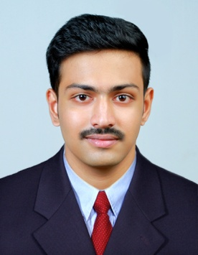

**ASHIN.K.RAPHEL**

Koonissery House

Mundathicode P. O

Thrissur – 680601  
Kerala, India

Mob: +91- 8606925382

Email: ashinkraphel@gmail.com

CAREER OBJECTIVE:

To obtain a long term career with an organization, which provide good opportunity for enhancement of professional and personal status.

ACADEMIC QUALIFICATION:

|  |  |  |  |
| --- | --- | --- | --- |
| **Course** | **Institution** | **University** | **Year** |
| **SSLC** | **St. Thomas HSS, Thiroor , Thrissur** | **Kerala State Board** | **2013- 14** |
| **Plus Two Commerce** | **Assisi EMHSS , Thalakkottukra, Thrissur** | **Kerala State Board** | **2015- 16** |
| **BSC. Airline Tourism & Hospitality Management** | **Chavara Institute of Management Studies, Eranakulam** | **Bharathidasan University , Trichy** | **2019** |
| **Foundation in Travel And Tourism** | **Chavara Institute of Management Studeis, Ernakulam** | **IATA, Canada** | **2019** |

* **PREVIOUS EXPERIENCE**
* Completed 3 Months training as a tour operator from **ITL TOURS AND TRAVELS , RAVIPURAM, ERNAKULAM.**
* Currently working in **CARNOUSTIE RESORT , Alappuzha** as Restaurant steward and similar Hotel experiences.

SKILLS

* Communication
* Decision making
* Adaptability
* Creativity
* Team work
* Ability to work under pressure

PERSONAL PROFILE:

Father’s name : K.P. Raphel

Date of Birth : 30-7-1999

Gender : Male

Marital Status : Unmarried

Nationality : Indian

Religion : Christian

Languages Known : English, Hindi, and Malayalam

Hobbies : Travelling, Social Work, and Endurance Sports

PREVIOUS EXPERIENCE:

DECLARATION:

I hereby declare that the above mentioned information is correct up to my knowledge and I bear the responsibility for the correctness of the above mentioned particulars.

**Date:**

**Place:** **ASHIN.K.RAPHEL**