
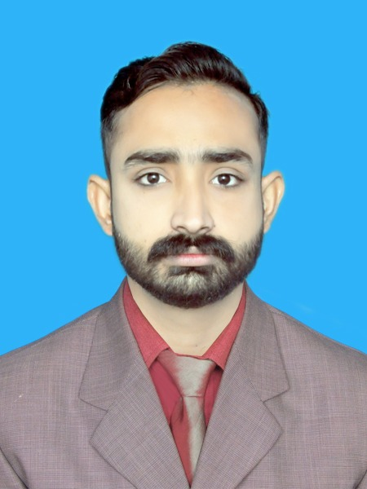
MUHAMMAD KASHIF
WORK EXPERIENCE
OBJECTIVE
- WORKING ON WATER FLOW MEASURMENT SYSTEM WLITH THE HELP OF PROGRAME LOGIC CONTROL (PLC) AND HUMAN MACHINE INTERFACE (HMI).

PROJECT – FINAL YEAR

Seeking a position in a well-established organization and looking for a challenging and dynamic atmosphere where I may show my hidden capabilities with the co-operative and sympathetic staff, with which I can use my all needed skills effectively and efficiently for organizational and personal growth and to serve my country “PAKISTAN”.

- WORKING ON PLC.
- WORKING ON HMI.
- DESIGN ANALYSIS
- CODING AND IMPLEMANTATION.
INTERNSHIP – XOHO TEC.
SALLE DE SPORT

April. 2020 - May. 2020





CAREER
Sept. 2019 - Sept. 2020
+971526493419

Xtylishrana11

xtylishrana490@gmail.com

ENGINEER
INTERNAL AUDITOR -AL-FATEH SHOPING MALL

Dec. 2020 - Nov. 2021

POINT OF SALE HEAD (POS) AT AL-FATEH
July. 2016 Dec. 2020

+971526493419

Kashif Ashiq

SOFTWARE


CONTACT
Highly recognized in the community, I can meet the challenges that your company will entrust me.

HOUSE# 112-E ALFLAH TOWN BEDIAN ROAD LHR Cantt

- INVENTORY MANAGEMENT.
- ENSURE ITEMS ARE IN STOCK AND MAINTAIN INVENTORY.
- WORKING ON INCOMING AND OUTGOING OF GOODS.
- CHECKING THE PRICE VARIANCE (PV).
- WORKING ON PORTABLE DATA TRANSMIT (PDT).

- MANGING CASH COUNTERS.
- CUSTOMER RELATION.
- MANAGING THE BAG CASH (OPENING CASH).
- CHECKING ALL DELETION AND VOIDED.

- DEALING WITH CASH.
- CUSTOMER RELATION.
- PROVIDES A POSITIVE CUSTOMER EXPERIENCE WITH FAIR, FRIENDLY SERVICE.
- WORKING ON CASH SOFTWARE S4U.
- REGISTER SALES IN SOFTWARE AND FINALIZING TOTAL SALE.

OUTBOND CALL CENTER RAÍZ LONDAN
July.2015 Oct.2015
- LISTENING TO CUSTOMERS NEEDS OR ISSUES.
- HANDLING MANY INBOUND AND OUTBOUND CALLS.
- MANAGEMENT AND RESOLVE CUSTOMER COMPLAINTS.

CASHIER AT YASIR BROST
Jan. 2016 Apr. 2021


MUHAMMAD KASHIF

AutoCAD
SolidWorks
25 WPM (Word Per Minute)
Adobe Photoshop

National College of Business Adminstration & Economics
Service Rd, DHA Phase 8 Lahore, Punjab
BSCS

Oct. 2016 - Sept. 2020
- Feb. 2018
ENGINEER
EDUCATION
Govt. Khawaja Saad Rafiqu College
Walton Road,Lahore,Punjab,Pakistan
FSC PRE-ENGINEERING

Sept. 2014 - Aug. 2016
- Feb. 2018
MATRICULATION (BIO SCIENCE)

SOFTWARE


COMPETENCES
Microsoft Office
(Word, Excel, PowerPoint)
Sept. 2011 - Aug. 2013
- Feb. 2018


INTERESET
LANGUAGES
Filmora, Camtasia, Adobe Premier Pro

- English : Fluently
- Urdu : Native
- Punjabi : Fluently
Friends Beacon school
Bhatta Chowk,Lahore,Punjab,Pakistan
HARD SKILLS
- Wathcing News
- Learn New Things
- Watching Machines Documemtry
- Reading Books

- Computer Skill
- Presentation Skill
- Management Skill
- Analytical Skill

SOFT SKILLS
- Interpersonal
- Teamwork/Collaboration
- Communication
- Detail-Oriented
- Multitasking
- Problem Solving
- Writing
- Decision Making
- Creative Thinking
- Public Speaking
- Customer Service

