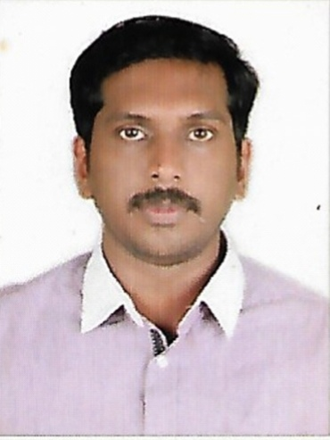 |  | Arunbabu k  Contact details  Contact no: +919567673923( Whats App )  EMAIL:  arun.kailas20@gmail.com
Career Objective:  To prove the capabilities in the challenging work atmosphere. To be a part of professional environment to grow as a professional. To work in an innovative team-environment and make a fruitful contribution in attaining organization’s goals.  PROFESSIONAL PROFILE:  I am an enthusiastic and professional experience who enjoys being part of a leading, successful and productive team. I am able to work well on my own initiative and can demonstrate the highest levels of motivation required to meet the tightest of deadlines and having the ability to perform effectively even under significant pressure.  COMPUTER KEY SKILLS:  - PROGRAMMING IN C  - PROGRAMMING IN C++  - VISUAL BASIC 6.0  - PHOTOSHOP  - MS OFFICE  COMPUTER PROFICIENCY  - Sound knowledge in MS Office (Excel, Word, Power Point,)  SKILL PROFILE:  - Highly motivated and dedicated to project teamwork. I have successfully been involved in various teams within both academic and non-academic environments.  - Ability to manage multiple tasks and meet tight deadlines and targets.  - Excellent communication ability, good problem solving skills, strong numerical and analytical skills, excellent interpersonal skills, and a desire to work to my full potential.  KEY STRENGTHS  - Positive  - Attitude  - Confidence  - Perfection  - Creative  - Polite  - Fast Learner  PERSONAL DETAILS  Date of birth : 30-05-1985  Place of birth : INDIA  Marital status : Married  Nationality : Indian  Passport No : N1538719  Place of Issue: JEDDAH  Date of Issue : 16/12/2015  Date of expiry : 15/12/2025  Languages known:  English, Arabic, Hindi, Tamil, Malayalam  Permanent Address : Arunnivas,  Muthukulam South P.O,  Alappuzha Dist,Kerala  Pin.690506.  Phone :- +971581529819 |  | Employment Summary:  Organization / Employer Position Duration Summary of Project  SAUDI MARKETING COMPANY LTD, KSA IT SUPPORT MAR 2011 - SEP 2016 Updating change prices, Make Receive&Return Invoice, Make Order To Whare House, Make Purchase Orders To Suppliers, Yearly Inventory Controlling, Making Daily Bases Reports, Installing software,Cofigure & Troubleshooting From Hardware and Software issues  GRAND HYPERMARKET, JALEEB, KUWAIT CASHIER JULY 2017 - SEPT 2017  LULU EXCHANGE WLLCO. FHAHEEL, KUWAIT TELLER OCT 2017 - JAN 2017 SENDING AND RECEIVING MONEY FROM CUSTOMER, FORGIEN CURRENCY EXCHANGE  SAUDI MARKETING COMPANY LTD, KSA IT SUPPORT OCT 2017 - FEB 2020 Updating change prices, Make Receive&Return Invoice, Make Order To Whare House, Make Purchase Orders To Suppliers, Yearly Inventory Controlling, Making Daily Bases Reports, Installing software,Cofigure & Troubleshooting From Hardware and Software issues  Duties and Responsibilities:  - installing and configuring computer hardware operating systems and applications;  - monitoring and maintaining computer systems and networks;  - talking staff or clients through a series of actions, either face-to-face or over the telephone, to help set up systems or resolve issues;  - troubleshooting system and network problems and diagnosing and solving hardware or software faults;  - replacing parts as required;  - providing support, including procedural documentation and relevant reports;  - following diagrams and written instructions to repair a fault or set up a system;  - supporting the roll-out of new applications;  - setting up new users' accounts and profiles and dealing with password issues;  - responding within agreed time limits to call-outs;  - working continuously on a task until completion (or referral to third parties, if appropriate);  - prioritizing and managing many open cases at one time;  - rapidly establishing a good working relationship with customers and other professionals, such as software developers;  - testing and evaluating new technology;  - Conducting electrical safety checks on computer equipment.  - analyzing user requirements;  - researching, designing and writing new software programs;  - evaluating the software and systems that make computers and hardware work;  - developing existing programs by analyzing and identifying areas for modification;  - integrating existing software products and getting incompatible platforms to work together;  - creating technical specifications and test plans;  - writing and testing code and then refining and rewriting as necessary;  - writing operational documentation with technical authors.  EDUCATION.  - SSLC from Kerala State Secondary Board, affiliated to the, Samajam HSS, Muthukulam , Kerala, India in 2000.  - VHSC from Muthukulam Higher Secondary School Affiliated to the Higher secondary Board, , Muthukulam, Kerala, India in 2003.  TECHNICAL QUALIFICATIONS.  - DIPLOMA IN COMPUTER APPLICATION, HR&DCC, Chingoli, Kerala, India .  - Successfully completed the Course of diploma in Hardware, Laptop Servicing Wi-Fi Networking BITS,Haripad,Kerala,India  - Completed VB.net course from SASTA INFOTECH Ernakulum, Kerala, India  COMPUTER PROFICIENCY.  - Operating Systems : GUI (Windows XP, 7, 10, Linux). CUI (DOS)8  - Programming Languages : C/C++,VB 6.0,VB.Net  - Query Languages : SQL 2003  - Packages-Micro soft office XP,2003,2007,2010,2013  - Computer Hardware : FAMILIARITY with Intel-compatible Hardware, building and configuring Machines, hard ware trouble shooting  DECLARATION  I hereby declare that all the above mentioned information is true to the best of my knowledge and belief  Place: ARUN BABU K  Date:

