Farhan Mahamood  Sales Executive |  | 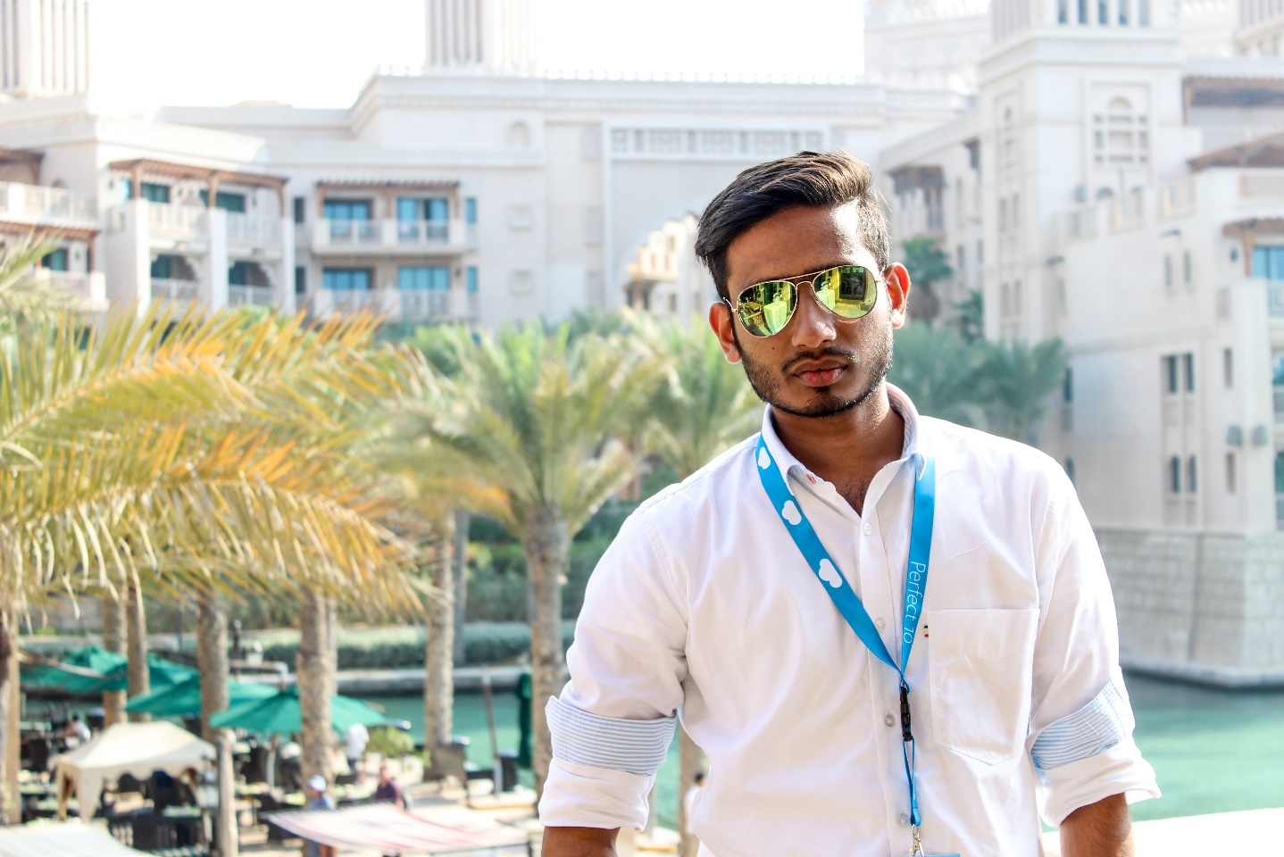

Objective
To work in a position where I will increase gains in profit performance, revenue growth and market share by using my expertise and skills in business management and entrepreneurial drive.

Experience
Oct 2019–April 2020 [Abu Dhabi, U.A.E]
Sales Executive • Supervisor • Oppo Mobiles
March 2019–Aug 2019 [Bangalore, India]
Tele Sales Executive • Team Leader • NoBroker.com
Nov 2016–April 2018 [Abu Dhabi, U.A.E]
Sales • Marketing • Huawei Mobiles
March 2014–April 2016 [Dubai, U.A.E]
Sales • Brand Ambassador • Microsoft
March 2012–Feb 2014 [Dubai, U.A.E]
Sales • Incharge • Hendi Al Shamsi General Trading
8 years of experience in sales, marketing and customer service has developed my skills in sales, customer handling, effective closing of sales as well as team management and product preposition.

Education
Jaipur National University – Dubai, U.A.E
- Bachelor of Computer Application

Christ College – Thalassery, Kerala, India
- Higher Secondary

Sunrise English Private School – Abu Dhabi, U.A.E
- High School

Communication
Excellent communication skills and proficient in several languages like English, Hindi, Malayalam, Tamil and Arabic. Able To communicate with customers in a very experienced and professional manner.

Key Skills
- Excellent computer skills in Windows & Android systems, MS office, Microsoft solutions.
- Knowledge in Python, JavaScript, HTML and CSS
- Excellent knowledge on mobile devices technical support.
- Able to communicate with customers efficiently and in Professional manner.
- Languages English, Hindi, Malayalam & Arabic (Read &Write).
- UAE light vehicle License and Knowledge of UAE roads.
- Accuracy and Speed in Data Entry/Word processing.

Objective
- Date of Birth : 21-12-1990
- Passport no : J1885072
- Driving License no : Yes
- Sex : Male
- Marital Status : Married
- Nationality : Indian

I do hereby declare that the above given statements are true to best of my knowledge and belief. I assure you that I will do my level best to discharge the entire satisfaction of higher authorities.

 |  | Contact
Madinat Zayed
Abu Dhabi, U.A.E
 |  | +971-56-872-8239
 |  | farhan.iml@hotmail.com

