**CURRICULUM VITAE**

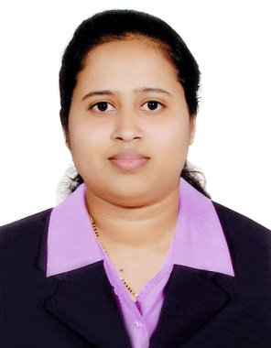

**Laiza Mathias**

**Mail:** [**mathiaslaiza30@yahoo.com**](mailto:mathiaslaiza30@yahoo.com)

**Mobile no : 0556618090**

**OBJECTIVES:**

To have career in an organization with challenging assignments that will widen my horizons, enrich my learning experience and provide with an environment that will top my talent to the full potential and that allows me to grow with the organization.

**WORK EXPERIENCE:**

* **Worked at Omega Hospital Mangalore from 1stJuly2011toOct**

**2013**

* **Worked At Pathway global Dubai As a Receptionist from 2014 January to June 2014**
* **Worked At Accurate Radiators Dubai As Receptionist From 2015 march to 2016 Jan**
* **Worked At Evergreen auto Garage as a Receptionist cum coordinator from Aug 2017 to Jan 2020**

**JOB PROFILE:**

* Appointments for customer and business meetings
* Preparing bills, handling day today cash.
* Maintaining customer relationship through mass E-mail and tele- marketing.
* Managing administration stationaries..
* Maintain an accurate filing system, updating all office files.
* Prepares and fallow up enquiries to suppliers.
* Answer and screen telephone calls, responding to telephone inquiries and follow up effectively.
* Prepare invoices, reports, memos, letters, and other documents, using word processing, spreadsheet, and database.
* Read and analyses incoming memos, submissions, and reports to determine their significance and plan their distribution.
* Open, sort, and distribute incoming correspondence, including faxes and email
* Sending quotations to customer..
* Greet visitors and determine whether they should be given access to specific individuals
* Over all office administration.

**STRENGTHS AND CAPABILITIES:**

* Flair for interacting with people.
* Able to analyze situations and work efficiently.
* Good knowledge of computers.
* Able to work within a team & individually.
* Good communication and interpersonal skills.
* Ability to win the trust and confidence of seniors, colleagues and team members.
* Pro-Active, performance oriented, hardworking and dedicated to the job.
* Ability to work in a fast paced environment.

**EDUCATION:**

SSLC : Little Flower High School Kinnigoli in 2005April.

Secondary : Pompei pre university collage Aikala from 2005 June to2007 March.

GNM : Alva’s institute of nursing science June 2007 to January 2011

### PERSONAL PROFILE:

Name : **Laiza Mathias**

Date of birth : 30th Jan 1990

Gender : Female

Civil status : Married

Nationality : Indian

Languages known : English, Hindi, Kannada, Konkani

Contact Number : 0556618090

### DECLARATION:

If I get an opportunity in your esteemed company, I will put on my highest efforts to achieve the desire result and prove my ability. I hereby declare that the information mentioned above is true & correct to the best of my knowledge & belief.

**Name: Laiza Mathias**