RESUME

MOHAMMMAD ASIF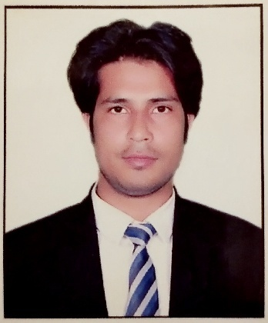

Add- G 59/10 third floor Batla house

Jamia Nagar okhla

New delhi 110025

Mob: +971523356977

Email:Asifsalmani717@gmail.com

**CAREER OBJECTIVE:**

To work with an organization in learning and challenging environment that supports me in my personal development, utilizing my skills and knowledge acquired during my professional and academic experience to be the best of my abilities and contribute positively to my personal as well as growth of the organization.

**ACADEMIC QUALIFICATION:**

|  |  |  |  |  |
| --- | --- | --- | --- | --- |
| **Qualification** | **Year** | **University/Board** | **Institute** | **Percentage/ CGPA** |
| Graduation  (BBA) | 2012-2015 | PTU | NEW DELHI INSTITUTE OF MANAGEMENT, OKHLA,  NEW DELHI | 55% |
| 12th  (Commerce) | 2012 | UP BOARD | SHORAT INTER COLLEGE NOUGWNA SADAT,U.P | 54% |
| 10th | 2010 | UP BOARD | S.R.K INTER COLLEGE  BADSHAPUR, U.P | 51% |

**COMPUTER PROFICIENCY:**

Completed computer basic course

MS- Word, Excel & Power Point

**Work Experience :**

**Organization**: : Acers AND Inches ( internship )

Duration : From 5th June 2015 to 7th August 2015 (2 months)

Roles Performed:

Business development Executive ( B2C Sales)

Promoting various types of Flats and Plots among new customers.

**Organization:** Applect Learning Systems Private Limited(Meritnation.com)

Duration : March 2016 to Apiral 2018(25 months)

**ROLES PERFORMED : Sales executive**

1.Generating Leads through Calling

2.To convert calls into meeting

3.Converting meeting into sales

4.Building Relationship with Clients

|  |
| --- |
| Organization:Tele performance  Duration : JULY 2018 to May 2020 (22 months)    ROLES PERFORMED: Sales executive  Selling of Axis Bank credit cards through calling  Lead Generation for personal loan. Business loan .Home loan.auto loan |

**CORE MANAGEMENT COMPETENCIES:**

Highly motivated and eager to learn new things.

Ability to work as individual as well as team

Hobbies:

* **Socializing** – Community work, **Volunteer** Work.
* Animal Care

**• Traveling**

**PERSONAL INFORMATION:**

Father’s Name : Mr.Abrar Ahmed

Date of Birth : 15-06-1993

Languages known : Hindi, English

Marital Status : Single

Gender : Male

Nationality : Indian