Mr. CP SREEJITH
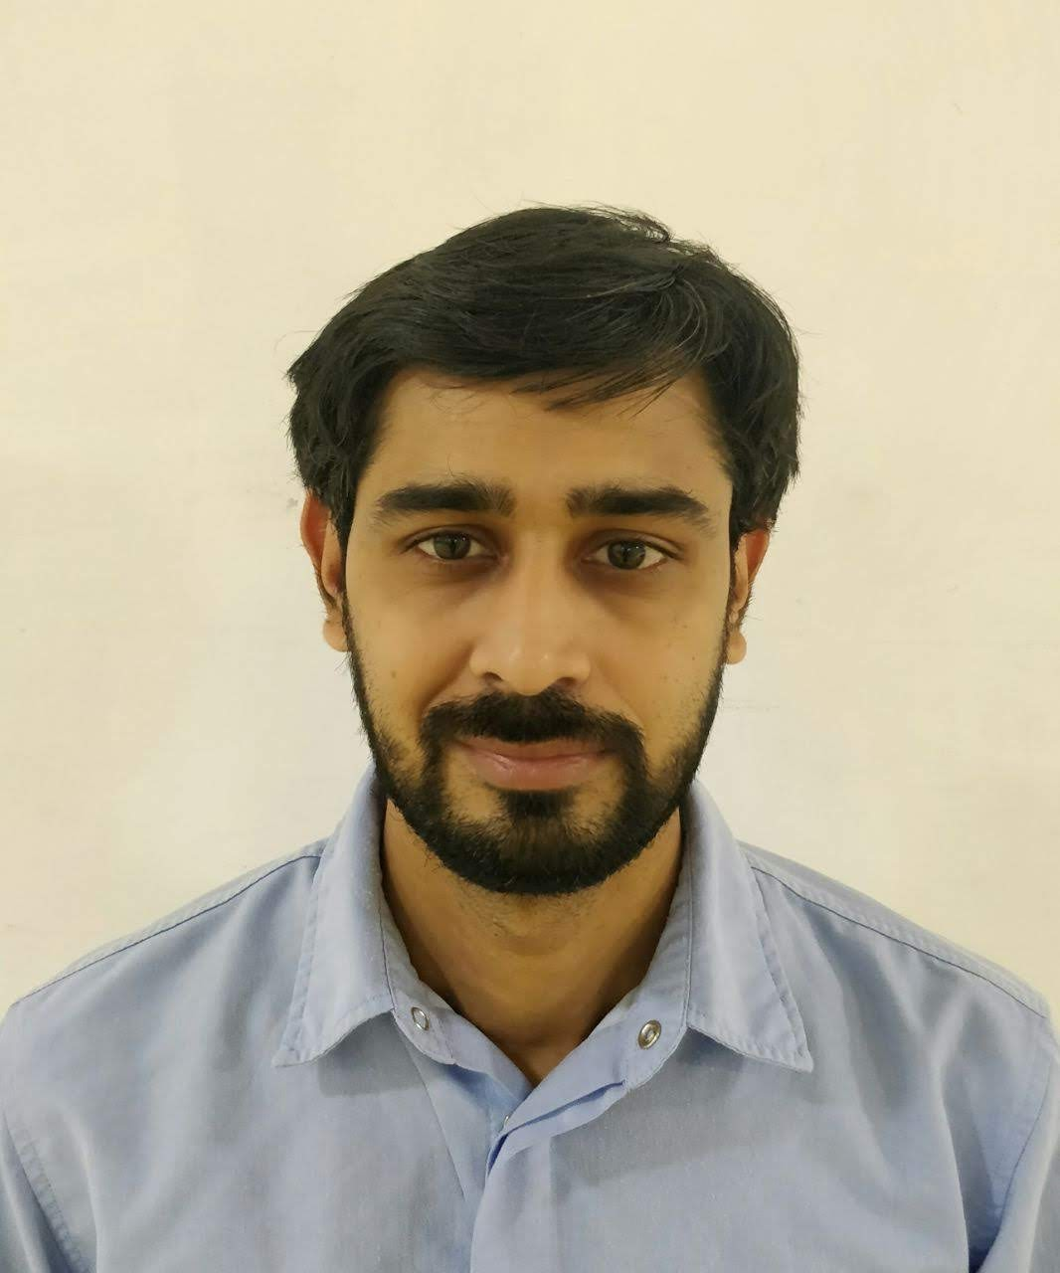

Phone: +971-554238171
Dubai, UAE Email: cpsreejith123@gmail.com

OBJECTIVE
Seeking challenging position in Supply Chain, Planning, Manufacturing, Engineering or Operations where my overall management and technical background, along with the leadership and decision-making capabilities, will be combined to render the most benefit to the company and my personal and professional development.

Areas of Expertise

Manufacturing/maintenance Mgmt Process Improvements/Innovations Productivity Enhancements
Project planning / Execution/Mgmt Quality Management Cost & Budgetary Control Resource Allocation & Mgmt Training/ Man Management Material planning
Operation management Manpower Supervision Supply Chain
WCM Production Planning & Control

PROFESSIONAL EXPERIENCE

VVF GROUP –GREEN PLANET INDUSTIRES LLC May 2018 –Till date
Assistant Manager -Operations

- Ensure the achievement of monthly production targets for different SKUs & adherence to the plan in respect of quantity and quality.
- Increase line efficiency and target to achieve 80% OEE.
- Training the Executives and Officers as per training calendar.
- To maintain line balancing & Productivity and optimization of manpower.
- Ensure strict adherence to SOP for line clearance, inprocess controls and line start up checks. Responsible for production planning & scheduling manufacturing operations.
- To anticipate breakdowns of machines and take proactive and preventive action.
- To actively participate in addressing environmental, occupational, health and safety issues.
- Plan the production with the planners.
- Detailing of operations, MIS generation and reporting.

HINDUSTAN UNILEVER LTD Aug 2010 –May 2018
Production Executive

- Manufacturing, Production planning & scheduling manufacturing operations.
- Plan and execute the production schedule including human and material resources.
- Reducing of Packaging Material cost of incoming Material through recycle of Packaging Material & by increasing the size of the laminate Rolls from 150 kgs to 800 kgs.
- Regular communication with internal customers to meet production-oriented requirements.
- Generating weekly reports Operational efficiencies and reporting the same to Factory & Production Managers.
- Taking projects to increase OEE of machines.
- Ensuring Work Safety, Road Safety and SHE aspects.
- Doing all Risk Assessments in the Plant.
- Monitoring and reviewing production, quality, machine and technical efficiencies and reporting.
- Collaborate with receiving and production personnel to review inventory levels and determine shifts in production areas that would limit materials and supplies held on hand.
- Workman appraisal-JSP and based on that Annual training calendar.
- Inventory Reconciliation
- Oversee utilization of staff resources and migrate workers to key areas to optimize production
- Support in installing machine and equipment.
- Planning for Monthly Maintenance of Machine.
- Handling of Filling Lines (Rotary Lines).
- Undertaking a daily track of (OEE) Overall Equipment Efficiency basis the individual machines
- Motivate new operators for new certification skills.

MARICO LTD Aug 2008 – Aug 2010
Planning and Production Executive

- Production planning & scheduling.
- To attend mechanical breakdowns.
- To prepare MOR (Monthly Operational Review)
- Responsible for ensuring safety in filling department.
- Ensuring fatigue free and safe working environment
- Complies and monitors production schedules and adjusts staffing to meet production schedule.

GKB VISION PVT LTD Dec 2006 – Aug 2008
Planning and Production Executive and Oven Dept Head

- Responsible for all the operations & processes carried out in the glass manufacturing industry.
- Responsible for achieving quality & keeping track on production by down Time analysis, quality & Production reports.
- Ensure high customer satisfaction ratings, maintain production goals and reduce inventory carrying costs.
- Safety coordinator for oven department.

STARFLEX SEALINGS PVT LTD (Gasket Manufacturer) Sep 2004– Nov 2006
Planning and Quality Executive
- To make production planning to cater to customer requirements.
- To monitor various parameters of products at various stages for Quality.
- Achieving required quality.
- To make internal inspection report.
- To achieve maximum productivity.
- Manage logistics, shipping, receiving, delivery and distribution including process improvement and problem resolution.

AREAS OF EXPOSURE

Operations

- Planning and Sourcing of Packing material/Raw material.
- Hands on experience on high-speed Rotary Filling Machines like Serac, Auto pack,
- Hands on experience on pouch machines like Mespack, Hassia, FFS, CEKA, Brick pack and on Linear a filling machine
- Implementing internal control plans for manufacturing operations of equipments and machines as well as standard products ensuring accomplishment of business goals.
- Maintain man machine relationship through TPM
- An active member during Level-2 journey and audit by JIPM japan.
- An active member during WCM journey and audit by FIAT.
- Having end user experience on TPM/WCM, Continuous Improvement tools. e.g. ECRS, 5S, WWBLA, PPA.
- Preventive and Breakdown Maintenance.
- Leading EEM pillar in the factory.
- RM/PM, Production planning & resource planning of beverage and Packaging units, Homecare & personal care unit.
- Maintenance, Operational and Trouble Shooting experience on packing lines.
- Proactively identify areas of obstruction / breakdowns and take steps to rectify the equipments through application of trouble shooting tools.
- Monitoring and control of wastages RM and PM in Packing and other areas.
- TPM & WCM implementation and continuous execution in shop floor. .
- Inventory management, work scheduling and cost control.
- Conducting SAM’s & CEP execution.
- Perform audits for new suppliers to assess manufacturing activities and logistics

Quality Control

- Streamlining the working SOPs for enhanced operational effectiveness.
- Conducting systems audits at various plant departments.
- Conducting Process Health Check Audit as Per Unilever Guidelines.
- Periodic validation of special processes
- Developing service standards and operating procedures with latest knowledge and modern skills for achieving business excellence in coordination with Stakeholders, Suppliers and Customers.
- Monitoring quality systems and compliance with preset standards, troubleshooting and maintaining requisite documents to ensure complete in process quality and improvement in process capabilities.

Projects
- Commissioning & stabilization High speed filling line Serac, Weight pack.
- Commissioning & stabilization of ROBOT (KUKA) for high-speed packing of bottles.
- Commissioning & stabilization of Possimat (Bottle unscrambler) and Lantac. (Auto case packer).
- Smooth relocation of Athal tea plant to Amli without any loss of team target & business target.
- New equipment installations and procedure writing.
- To reduce excess, give away on all machines using TPM tools WWBLA.
- SKU changeover time reduction in Serac and Autopack.
- Maintenance time reduction in Vacuum chamber.
- Skill matrix for Operators and Officers.
- Projects related to CEP, work simplification and safe.
- Capacity enhancement on high-speed lines.
- Installation and Stabilization of New Vaccum pack trapezium shape machine, Hassia Machine.
- Elimination of External Warehouse: Company had recurring expenses of Rent, Management Charges & Operating Expenses on External Warehouses. Developed a plan to eliminate external warehouses by creating in-house space

Procurement

- Processing PRs, POs, service orders and work allocation.
- Agreement tie-up, vendor evaluation and negotiations.
- Regular communication with internal customers to meet production-oriented requirements.

Man Management

- Directing and leading the technical personnel. Imparting continuous on job training to the workforce for accomplishing greater operational effectiveness / efficiency.

Finance

- Budgeting and Costing.
- Forecasting R&M Budget for the Factory.

ACADEMIC DETAILS

- B E in Mechanical Engineering from Goa University (2000-2004): ---1st Class—64.29%.

- PG MBA in Operations Management from Sikkim Manipal University (2008-2010) :---First Class 62.25 %

TRAININGS ATTENDED

- Attended DuPont Safety System Manager’s/Executive’s Training and been Certified.
- Attended Frontline Leadership Development Programme for Manager’s/Executive’s Training and been Certified
- Attended TPM FACILATOR Training and been certified.
- Course attended on Basics of Supply Chain.
- Course attended on TQM. (Total Quality Management).
- Attended a training programme on Team Working, Emotional Intelligence, Generating creative and Innovative Ideas, Goal & Goal setting by Hindustan Unilever ltd.
- Course attended for Introduction to Six-Sigma
- Course attended on TQM. (Total Quality Management).

COMPUTER PROFICIENCY

- ERP : SAP (End user exp).
- Office Tools : MS- Excel, Word, PowerPoint.
- Designing Tools : Auto Cad,Pro-E ,Solid works
- Languages’ known : English, Hindi, Malayalam & Konkani

STRENGTHS & ACHIEVEMENTS
- Good analytical skills & good leadership skill.
- Proven skills in problem solving, co-ordination & analyzing.
- Determined and passionate towards work, task, assignments.
- By using WCM approach make Lid smear quality defect zero, reduce changeover time, make plug jam and puck jam minor stoppages zero & unlock manufacturing capacity and there by improved the output and Reliability of the machine and participated in South Asia level Kaizen Competition & won the award for unit.
- Articulate and quick learner.
- Improved the packaging machines & Plant OEE by using various WCM & TPM tool.
- The zone under my control has been declared as zero LTA (Loss Time Accident) zone for the year.
- Best circle Award winner in 5S & JH implementation in the plant.
- JH Champion (TPM PILLAR) 2008/09in Marico Goa Plant
- Record breaking production on CNC machine.
- Attended TPM FACILATOR Training and been Certified
- Record breaking production in Sachet machine

HOBBIES AND INTERESTS

- Playing Football, Volley ball, Cricket.
- Photography, Browsing.

PERSONAL DETAILS
- Date of Birth: 21 August 1982.
- Sex : Male
- Marital status: Married
- Languages’ known: English, Hindi, Malayalam & Konkani

