# Profile

* Detail-oriented, efficient and organized Accounting professional with 7 years in the UAE.
* Possess strong analytical and problem solving skills, with the ability to make well thought out decisions and adapting new approaches, tools & environment.
* Good in oral and written communication Skills/interpersonal communications.
* Consistent performer and dedicated team player who can work under pressure and meet deadlines.
* Proficient in preparing financial Statements like Trial Balance, Profit & Loss statement, Balance Sheet, Cash Flow statement,

# Experience

**ACCOUNTANT/ADMIN** – November 2011 –February 2019

**International Courier and Cargo Service (ICCS Express)**

**Dubai U.A.E**

* Preparing Profit and loss Statements.
* Forecasting Income and Expenses, Bank reconciliation.
* Account receivables and Account Payables.
* Monitor and review other system related reports, Payroll.
* PreparingVAT reports.
* Process company documentation and licensing.
* Maintain employee records.
* Handling employee complaints and offering administrative support.

**Project Accountant/Project Coordinator** - July 2010 – February 2011

**Computer Revolution Africa,Addis Ababa,Ethiopia**

* Coordinating project schedules, resources,and infomation.
* Arranging workshops and trainings.
* Ensuring the effective preparation and delivery of all project events and meetings and producing all necessary documets.
* Bank reconciliation.

**ACCOUNTANT-** December 2008 - June 2010

**Africa Insurance Company Addis Ababa, Ethiopia**

* Customer account analysis.
* Weekly reports on Collection and payment.
* Supervising account Clerks and authorizing Petty cash funds for branches.
* Assist in preparing Financial Statements, Budgeting,and Payroll.

# Education

B.A., Degree in Accounting & Finance ,2007

Addis Ababa University, Ethiopia

# Other Certificates

**International Diploma in Project Management**

**CAREER OBJECTIVE:**

To work hard with full dedication for the achievement of organizational objectives and to be a part of a company that is multicultural and promotes institutional, professional, individual growth and values its employees, thus enabling to fully maximize growth and build a career and serve as a ground for my educational and professional development.

**B.A., Degree in Accounting & Finance**

Mobile: +971557846020

Emails: [wongelnegga@yahoo.com](mailto:wongelnegga@yahoo.com)

wongeleyob@gmail.com

Dubai, United Arab Emirates

**Nationality**: Ethiopian

**Visa Status**:-Husband Visa

UAE Driving License

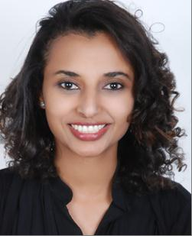

**Wongel Eyob Negga**