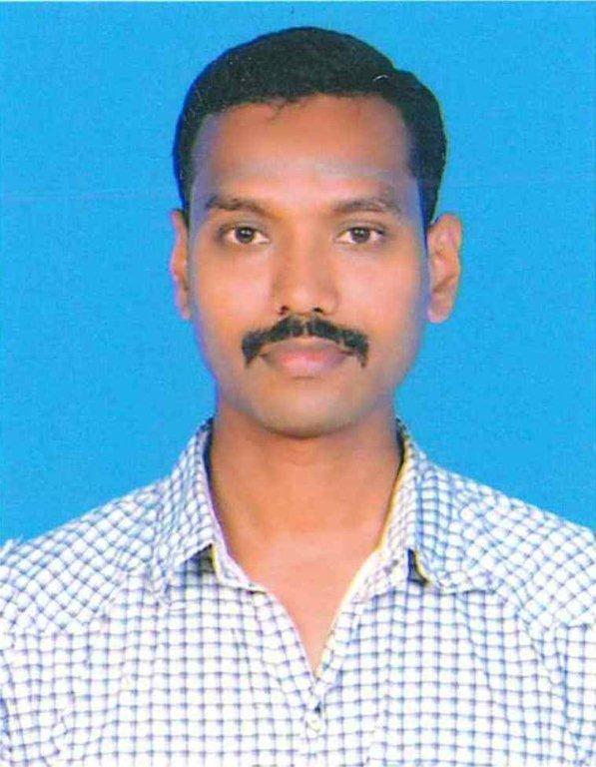
Curriculum Vitae
S. CHITTYBABU
MOBILE : +974-66253822
MOBILE : +91-9443249413
E-Mail: sbabu1980.cbb@gmail.com

Seeking for the post of QC Sr. Inspector of Piping & Welding in Oil & Gas Construction field with a growth-oriented organization.

Professional Synopsis

Moreover past (16+) years of Process / Construction plant Inspection experience, I Have taken advantage of many learning opportunities with the goal of achieving strengths in All phases of Petroleum Refinery Inspection, Oil & gas plants New Project Construction. My work experience Includes Expertise in inspection of field and shop welding, interpretation of piping & Pipeline isometric and layout drawings, and determining the most effective NDT equipment to perform visual and NDT examinations Coordination with all execution and related departments for qualification of WPS and Welders. (Inspection of Pressure Pipe, Process Pipe, Pipeline, Static Equipment’s, Structures and Hot Tap). Good Knowledge in interpretation of drawings, Codes, Specifications and QA/QC procedures will be conversant with international standard such as ASME SEC IIA, IIC, V, VIII, IX, B31.1, B31.3 AWS D1.1 and API 1104 etc.
Construction Activities related on, fabrication, Plant piping. Onshore modules Installation, piping activities, Welding activities, Hydro testing, Pre-commissioning, and commissioning, Completion, shut Down Etc...
Educational Qualification
- Diploma in Mechanical

Technical Qualification

- CSWIP 3.2.2 Senior Welding Inspector (Cert.No.:443753)
- ASNT NDT Level II (LT, UT, RT, MT & PT)

SAFETY TRAINING COURSE
- Attended HSE Training- IIF by JMJ Associates, H2S, Goal Zero, BA, Confined space entry, PTW etc.
- Attended HSE Training- Shell Pearl GTL Ltd, QP, Qatar Gas, Oryx, ADCO, YLNG
- Attended Flawless Trainings - Shell Pearl GTL Ltd
- Attended Wendell Hull Authorized Oxygen Trainings (Oxygen service cleaning & Inspection requirements)-Shell

Organizational Experience

Company : Black Cat Engineering & Construction W.L.L (Qatar)
(From 12.08.2013 to Present)
Position : Senior QC Inspector (Piping, Welding & Testing)
Client : Qatar Petroleum, Oryx GTL, Qatar Gas, Qatar Shell GTL

AS Sr. QC Inspector Projects Worked:

Qatar Petroleum Dukhan: -
- EPIC for Sweet Fuel Gas Supply for Dukhan Consumer’s Project (SFGDC).
- EPIC for Upgrading the Instrument Air System at KNDS Within Dukhan Fields.
- EPIC to Upgrade the Turbine Air Intake Filtration System-Dukhan Fields.
- EPIC FOR ROUTE SURVEY, DESIGN, CONSTRUCTION, INSTALLATION & HOOK-UP OF WELL FLOWLINES IN DUKHAN FIELDS (2019-2022) - PART B(GC191008B0).
- EPIC FOR DUKHAN PRODUCTION FACILITIES UPGRADE (DPFU) - PHASE 1A - PACKAGE 1

Oryx GTL Ras Laffan: -
- EPIC FOR INTEGRATION OF UNIT-84 TFER WITH SCCB RLTO (MOC-577) client oryx gtl.
- call of CONTRACT FOR PROCUREMENT, INSTALLATION anD commissioning (pic) projects/ moc- client oryx gtl.

Qatar Gas Ras Laffan: -
- PROVISION OF THREE COMBINED EPC SHUTDOWN PROJECTS PROVISION OF INSPECTION OF MANWAYS-QG2 AND QG3 & 4 (LTC/E&V/1002(C)/08).
- PROVISION OF THREE COMBINED EPC SHUTDOWN PROJECTS 24HG9201 - BLOW DOWN LINE IN TRAIN 4 - QG2 (LTC/E&V/1002(C)/08).
- PROVISION OF THREE COMBINED EPC SHUTDOWN PROJECTS CONSTRUCTION/INSTALLATION WORKS FOR THE ADDITIONAL ESDVS ON TRAINS4&5(QG2) (LTC/E&V/1002(C)/08).
- FABRICATION AND WELDING WORKS IN TRAIN-2 SHUTDOWN, APRIL 2015 (LTC/VEN/2230-C/13).

Qatar Shell GTL Ras Laffan: -
- LP Steam Boiler Project SBLR (P-810040).
- O2 bleed valves upgrade O2BV (P-810093).
- O2 isolation valves upgrade OIV (P-810090).
- LPG Re-Routing to De-Ethanizer Project C1C3(P-810045).
- Addition of Level Nozzles NON-TA PROJECT ALNL(P-810100).
- LES PLUS NON-TA PROJECT LES (P-810078).
- WAX BACKFLOW PROTECTION PROJECT (P-810116).
- ETP Cluster NON-TA PROJECTS ETPC (P-810101).
- Flare Closed Drain Project FCDP (P-810108).
- HIO ONSHORE PROJECT HIO ONSHORE (P-810113).
- HOG HPS (Heavy Paraffin Synthetic) Off Gas (P-810121).
- ACC CONDENSATE DIVERSION (P-810142).
- WAX BACKFLOW PROTECTION PROJECT (P-810153).
- DRY GAS SEAL RELIABILITY PROJECT (P-810138).
- ETHANE EXPORT TO STATION A21 PIPELINE PROJECT (P-810127).
- OXYGEN IMPORT PROJECT (P-810301).
- BFW qmi cooling water jump over line PROJECT (P-810153).
- MULTI DISCIPLINARY CONSTRUCTION CALL OFF CONTRACT(CW394727).

Organizational Experience

Company : Rafidain Oil Services Co. Iraq
(From 26.01.2013 to 25.04.2013)
Position : QC Inspector (Piping, Welding & Testing)
Client : South Oil Company (SOC) Iraq.
Project : TUBA

Organizational Experience

Company : Petrofac International Limited
(From 03.04.2012 to 15.10.2012)
Position : QC Inspector (Piping, Welding & Testing)
Client : Abu Dhabi Onshore Oil Company (ADCO)
Project : ASAB Full Field Development Project
(Project Number: P14333)

Organizational Experience

Company : Hawk International Finance & Construction Limited
(From 03.05.2009 to 17.01.2012)
Position : QC Inspector (Piping, Welding & Testing)
Client : Safer Exploration & Production
Operations Co. (Yemen)
Project : YLNG Upstream Facilities Phase-I Modification Project
YLNG Upstream Facilities Phase-II Construction Project
(Project Number: SEPOC/ENG-2009.002)

Organizational Experience

M/S, Audco India L.T.D(India) Dec’03 to Dec’04

Valve Technician:

Working as a Valve Technician, works involved conducting Valve assembly, Leak Testing, Maintains & Repairing.

- Valve assembly. (Gate, Check, Butterfly, ball, Globe, Hot blaze & 3checklever).
- Valve hydro test, Pneumatic test, Bubble test, Halogen probe test, Cryogenic test & Helium detector probe test.
- Valve maintains.
- Valve Repairing.

Responsibilities:
- Material of the valve LCC, WCB, LCB, CF8, CF3, CF3M, CF8M, WC6, WC9. (Class-150 to 2500)
- Types of Valve Gate, Check, Butterfly, ball, Globe, Hot blaze & 3checklever Valve.
- Valve assembly.
- Valve internal testing.
- Testing witness by TPI (LRIS, BV, EIL, PDIL, IBR, UHDE, GL, TUV, ABS, SGS, RITES & IRS)

Main Challenges:

During the above employment periods my relevant duties and responsibilities related to Oil & Gas, Petrochemical, Construction, and pre-commissioning which included In-charge the Inspection & Supervision of piping system

Duties performed as QC Inspector:
- Monitoring and inspecting Incoming Material and verify the material test certificates correlation.
- Conduct the Fit-up inspections and ensures Material specification, dimensions, orientation against to the relevant latest revision of Isometric drawings and specifications prior to welding starts.
- Inspection of shop fabrication of piping spools and supports.
- Stage Inspection and Final Inspection of Welding, find out the defects, and explain to the welder to attend the Reworks.
- Witnessing of procedure Qualification Test and Welder Qualification Test (applicable code/specification)
- Monitoring and control welding parameters accordance to the WPS requirements.
- Inspection of welding consumables and equipment’s, checking of storage and baking of electrodes verifying all welding parameters according to approved WPS
- Vendor Assessment and Inspection of materials, Correction of mill certificates, dimensional checks, Condition of material, documenting and reporting of non-conformity (if any) to specifications
- Raising NCR’S and follows up for corrective actions. Review and Approval of concession requests.
- Inspection of pressure test (Hydro/Pneumatic and commodity Test) according to piping class, their test limit and required pressure.
- Witness of valve testing.
- Mechanical clearance for LOOPS and TESTING like Hydro test, Pneumatic test, Pad test and Leak test.
- Maintaining data for Piping spools-fabrication/welding / QC release/Painting / Release to site.
- Reviewing all QC/NDT documentations done by Subcontractor.
- To prepare daily inspection program and to carry out the inspection as per schedule, coordinating with client for inspection and releasing the activity to the execution team for further actions.
- Preparing pre-Punch list prior to hydro test.
- Visual Inspection of piping and preparing QC Punch list after installation and coordinate with the responsible field engineer or supervisor for its completion.
- Inspection and testing plans & ensuring that the inspection stages are properly defined and implemented.
- Inspects and monitors job site, verifies and tests a variety of features, such as quality of welding, coatings and materials used and reports any discrepancy in an inspection worksheet.
- Weld visual inspection of piping and structure Monitoring of various welding process like GTAW, SMAW and SAW.
- Review of engineering drawings like P&ID Isometric & PFD.
- Familiar in ASME, API, ASTM standards and procedures, and co-ordinate with the client for QA/QC Activities.
- Inspection for cleaning /gouge pigging / hydrostatic testing /drying and inserting.
- Mechanical, Welding & Hydro Test inspection for Oxygen service lines.
- Handling turnaround, Onshore fabrication and hook-up, Pipe inspection.
- Prepare and review Test Pack for System wise as per Project requirements.
- Line Checking Review of Hydro test packages, Line Checking and Review and clear the punch listing.
- Preparing the RFI (request for inspection) for prior to testing & inspection.
- Informing and getting approval of all site activities from the client through RFI.
- Experience in pre-commissioning activities such as water flushing and air blowing for all process Lines.
- Prepare and review Pre-commissioning Dossier as per Project requirements.
- Tie-in works and onshore mechanical & piping pre-commissioning and commissioning activities.
- Leak testing and Preservation with Nitrogen & Helium.

IT Skills

- Well versed with Windows, MS Office & Internet Applications.

Personal Details

- Father’s Name : S. SANTHANAM
- Date of Birth : 01st May-1982
- Nationality : Indian
- Languages Known : Tamil, English, Hindi & Malayalam.
- Marital Status : Married

PASSPORT DETAILS | TO CONTACT
PASSPORT DETAILS | Work | Home
Number : K7196407  Place of issue : Chennai  Date of Issue : 23-Nov-2012  Date of Expiry : 22-Nov-2022 | +974-66253822 | # 33, Kumaran Kudil, Malligai Salai, Vethavalli Nagar  Chidambaram-608001  Tamilnadu, India  Mobile:+919443249413
 | E-Mail: sbabu1980.cbb@gmail.com

