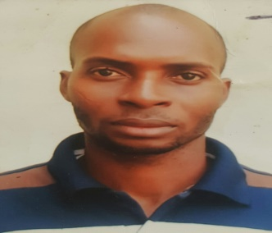**OLAOBAJU, EMMANUEL OLUWASEUN**

**DUBAI UNITED ARAB EMIRATE.**

**PHONE:** +971521127390

**PASSPORT NO:** A09858607

**EMAIL:** [emmanuelolaobaju@gmail.com](mailto:emmanuelolaobaju@gmail.com)

**VISA STATUS:** TOURIST VISA

**APPLUING FOR:** HOUSEKEEPING/CLEANING

**OBJECTIVE:**

To obtain job opportunities within your company and provide excellent service. Avid on the job learner excited to apply acquired knowledge while advancing skill set for the benefit of assisting with the growth of the organisation.

**SKILLS:**

* Ability to drive goals.
* Attention to details.
* Time Management.
* Good communication and effective writing.
* Computer literate
* Positive mentality.

**EXPERIENCE:**

**Skyview Hotel, Dubai Marina**

**Position: Cleaner**

**Responsibilities:**

* Daily cleaning of the reception and elevators in the hotel.
* Handled effectively cleaning of rooms, garbage rooms, and floor in the hotel.
* Ensured cleaning of the gym and swimming pool area are clean.

**Prime Hotel, Sango Ota, Ogun State 2004- 2006**

**Position: Cleaner/ Housekeeping**

**Responsibilities:**

* Daily cleaning of the reception and elevators in the hote.
* Handled effectively cleaning of rooms, garbage rooms and floors in the hotel.
* Ensured proper safety measure in toilet and proper hygienic
* Ensured all other important areas in the hotel are properly clean.

**EDUCATION:**

Obafemi Awolowo University, Ile-ife Osun state Nigeria

Bsc Accounting 2013

Local government secondary commercial school Atan-Ota Ogun State Nigeria

Senior secondary Certificate. 2003

**REFRENCES:**

Any additional references or information will be happily provided upon request.