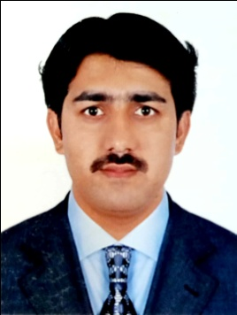**CURRICULUM VITAE**

**WASEEM ABBAS**

**Contact No. 055-2998191, 056-2017817**

**Email :** [**locksmithdubai8080@gmail.com**](mailto:locksmithdubai8080@gmail.com)

Dubai UAE

**POST APPLIED FOR: DRIVER JOB**

**CAREER OBJECTIVES**

To contribute in growth and profitability of the organization by providing efficient to all internal and external customer and to ensure smooth and uninterrupted functioning of work by ensuring availability of right quality of services (in terms of services) at the right time at optimum cost.

**WORK EXPERIENCES**

* Company : Qurtuba Locks – Dubai UAE
* Designation : Driver
* Duration : 2008 to 2012
* Company : Dar Al Dheyafah Watch Repairing – Dubai UAE
* Designation : Driver
* Duration : 2012 to 2016
* Company : Digital Expert Lock Repairing – Dubai UAE
* Designation : Driver
* Duration : 2016 to 2018
* Company : Qurtuba Locks Trading & Key Duplicating – Dubai UAE
* Designation : Driver
* Duration : 2018 to 2019

**Job Description**

**ACADEMIC QUALIFICTION**

* Metric Examination Completed – Kehkashan Public School , Pakistan (2002)

**PERSONAL INFORMATION**

Nationality : Pakistan

Date of Birth : 13/14/1984

Gender : Male

Marital Status : Married

Language Know : English, Arabic & Hindi

Visa Status : Visit Visa

**PASSPORT INFORMATION**

Passport No : JB1019383

Issue Date : 17/04/2017

Expiry Date : 16/04/2027

**DRIVING LICENSE INFORMATION**

License No : 3553249

Issue Date : 17/08/2015

Expiry Date : 24/08/2025

Vehicle Permitted : Automatic

Place of issue : Dubai UAE

I hereby declare that the above information are true and correct to the best of my knowledge and belief.

**Applicant**

**WASEEM ABBAS**