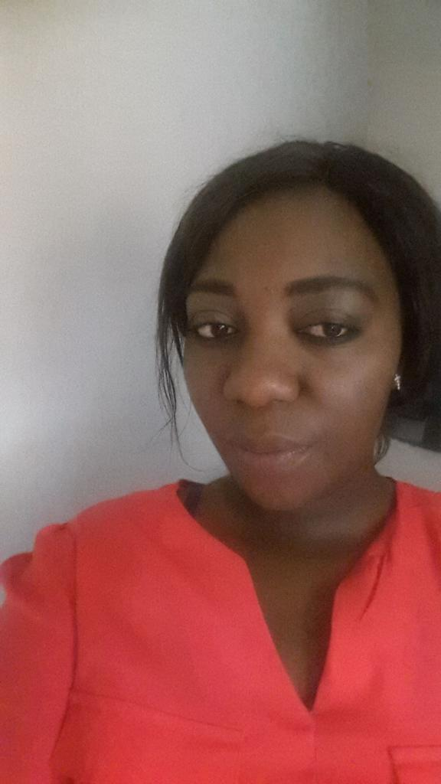

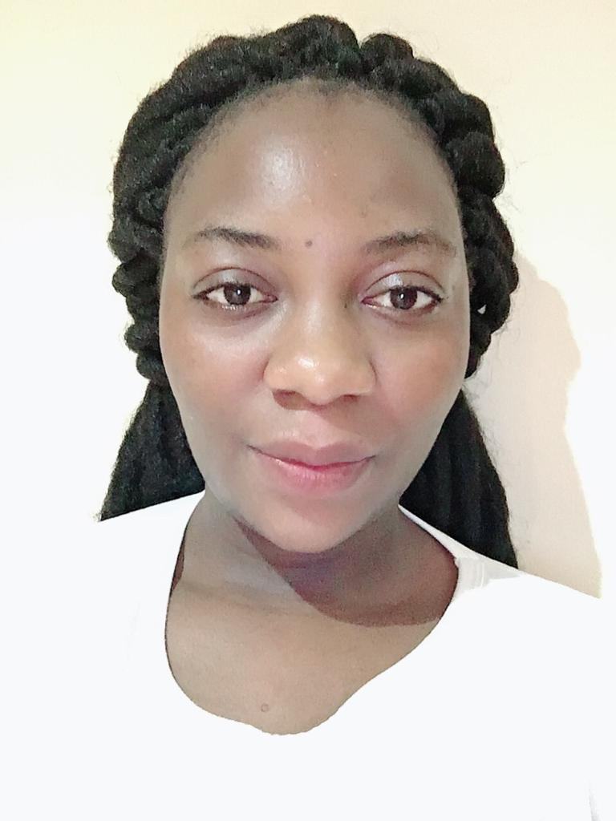

**Rutendo Natasha Madondo**

Contact No: +971557016576

Email Address: natashamadondo26@gmail.com

**Professional Summary**

Motivated hair stylist enthusiastic about hair industry,Dedicated to providing high quality color,braids and weaves.Excellent listener and communicator who works hard to make each client experience a positive one

Highlights

*Outstading customer service

*Flexble schedule

*Braiding and weaving

*Familiar with relaxers

*Cosmetology principles knowledge

*Business management

*Team player

**EDUCATINAL BACKGROUND AND QAULIFICATIONS**

Certificate in purchasing and supply- mutare polytechnic college 2013

Certified chartered procurement and supply personnel

**WORK EXPERIENCE**

**She & he beuty salon**

**Pretoria**

**South Africa**

Examined hair texture and condition to detennine appropriate braids style Educated guests on proper hair care.Recommended home care hair regiments and treatments set up workstation and treatment room with necessary product.equipments and supplies seleted hair extension colors based on customer preference .recomended hair styles that complimented clients facial feutures and coloring created repext business by developing lonh-term relationships with regular customers .politely answered the phone and schduled appointments for clients .Gained a solid expertise working with artificial hair ,shampoo and blow dry natural hair before applying extensions sanitized workstations and salon equipment for safety purposes.Developed new hair styling techniques using creativity and knowledge of trends.Offered clients a catalogue showcasing hair style options

Skills

* Energetic
* Hard worker
* Dedicated to providing excellent customer services
* Attentive to detail
* Strong teamwork skills
* Fluent in English

**PERSONAL PROFILE**

**GENDER**  : Female

**NATIONALITY** : Zimbabwean

**LANGUAGES SPOKEN** :English and Shona

**MARITAL STATUS :** Shona

**Declaration**

I hereby declare that above written statements are true in the best of my knowledge

**REFERENCES**

**Melon dhlamini**

**She & He beuty salon**

**pretoria South Africa**

**+27622410656**