RESUME

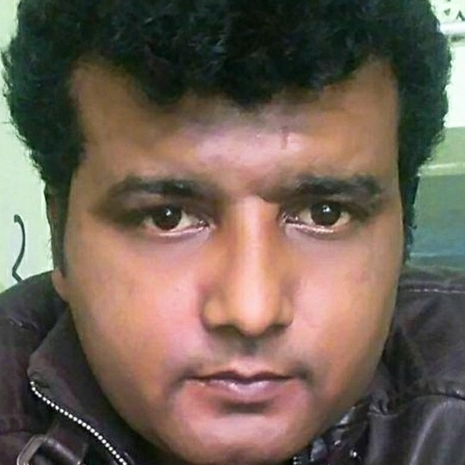**Mohd Nazim**

Mob No.: 9540512845

H-42, Okhla Delhi-25

# CAREER OBJECTIVE

Seeking to work in a challenging atmosphere to have better opportunities for learning and growth.

**Title:- Post Graduate with ten years experience in sales, customer service and operation.**

* **Working with Absass Solutions as a Senior Associate in Noida Branch from 4th Feb 2018 to till date.**

**JOB RESPONSIBILITY**

* Dealing with International clients over the phone, chat and mails on daily basis and provide the excellent customer service of the business as per the clients need.
* Dealing with other products and services through different channel.
* New clients acquisition through the cross and direct selling of the products and services and provide the pre sales and post sales support to the client in terms of the business.
* Coordinate with the admin and the operation team in terms of the client business.
* Prepare the daily MIS and the Excel to maintain the CRM.
* Handling the CRM clients of the process and provide the services.
* Handling the social media campaign like Facebook, Twitter, LinkedIn etc with the help of Digital marketing.
* Taking the interviews of the new agents and forward to the operation and admin team for the next level.
* Follow the KPI and the SLA provided by the manger & supervisor.
* Perform the business development activities with the clients in terms of the business.
* **Worked with** **Aegis Global India Pvt Ltd as a customer care Executive in Gurgaon Branch from 25th August 2014 to 18th Jan 2018.**

**JOB RESPONSIBILITY**

* Dealing with National & international clients over the phone, solving their problems over the phone.
* To provide the right resolution on the clients problem within a TAT.
* New clients acquisition through the different modes.
* Coordinate with the operation and administration team in terms of the clients business.
* Prepare the MIS of the customer on daily basis.
* Coordinate with the operation, admin and HR team in terms of the clients business on daily basis.
* **Worked with IBM Daksh as A customer care Executive in Gorgon Haryana Branch from 22th April 2012 to 22th July 2014.**

**JOB RESPONSIBILITY**

* Dealing with the US clients over the phone, chat and email and provide the excellent service in terms of the business.
* To provide the best resolution of the customer's complains and request within the time line.
* To achieve the daily an monthly target given by the supervisor and Manager.
* Follow the instructions and the guidelines given by the senior authority.
* Cord ate with the operation, admin and HR team in yes of the clients business on daily basis.
* **Worked with Vcustomer India Pvt Ltd as a customer care executive in Mohan- cooperative from 28th July 2010 to 8th Dec 2011.**

**JOB RESPONSIBILITY**

* Hardcore dealing with the US clients over the phone, chat and mail on every day basis and need to convert that lead into business to achieve the target given by the supervisor or manager.
* To provide the excellent customer service as per the company norms related to the process.
* To achieve the daily and monthly targets given by the supervisor.
* New clients acquisition through the cross dealing and cold calling.
* Coordinate with the operation, admin and the HR team in terms of the business of clients.
* To achieve the monthly and daily target given by the supervisor.
* To provide the resolution of the escalator cases on the best priority.
* Handling the CRM clients and provide the best service retated to business.
* Cross dealing of other products of the business to the clients.
* **Worked with Convergys India Pvt Ltd as an Assistant in Gurgaon Branch from 07th July 2007 to 05th October 2010.**

**JOB RESPONSIBILITY**

* To provide the best customer and technical support in terms of the process as per the clients need.
* Cross dealing of the other products through the call and chat.
* To achieve the daily, weekly and monthly target with the help of supervisor and the Manager.
* To coordinate with the operation, admin and the Human Resource department in terms of the clients business.
* New clients acquisition from the different mode of marketing and sales stragey.
* **ACADEMIC QUALIFICATION**
* **M.A.** English from Rohailkhand University in 2003.
* **B.A.**from Rohailkhand University in 2001.
* Intermediate from U.P. Board in 1998
* Matriculation from U.P. Board in 1996.

**PROFESSIONAL QUALIFICATION**

* Diploma in Computer Application from C.T.R.I Chandpur Bijnor 2004.
* Diploma in **Digital Marketing** from Google in 2018.

# COMPUTER SKILLS

* Operating System : Windows 98, 2000 and XP.
* MS Office : MS Word, Excel, PowerPoint.
* Internet : Net Surfing, Chatting, Searching

# DIGITAL MARKETING SKILLS

* SEO, SEM, Google Ad words, content Writing, analytical.

**PERSONAL DETAIL**

* Father’s Nasir. **:** Late Mohd Nasir
* Date of Birth : 05/07/78
* Email address. : [Creazy4@live.com](mailto:Creazy4@live.com)
* Skype ID :

**Place:-New Delhi. (Mohd Nazim)**