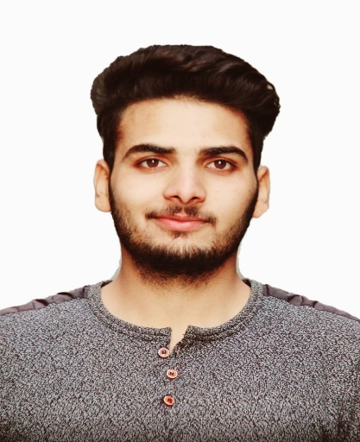  AAMIR SALEEM SHEIKH  Dubai, United Arab Emirates  Mob: +971567150180  Email: aamir0001x@gmail.com  Personal Data  Father Name: Mohd Saleem  Mother Name: Rukiya  Nationality: Indian  Marital Status: Single  Date of Birth :04/02/1996  Sex: Male  Visa Status: Visit Visa  Languages Known  English  Urdu, and  Kashmiri  Current address details:  Building Samaya 2  Flat No. 1304  Al Nahda, Sharjah UAE | Curriculum - vitae  Objective  - To build a long-term promising career with a reputed firm that encourages Professional growth through a wide range of challenging assignments for career growth.  CAPABILITY  - Good Communication & Presentation skills.  - Get along with a team.  - Hard cum Smart worker.  Educational Background  - B.TECH. in Electrical Engineering. From University of Kashmir’  Main subject (Solar PV systems )  - Auto CADD in Electrical Design Engineering  - Diploma in Computer Application (DCA)  - Three Year Diploma in Electrical Engineering from Jammu and Kashmir state Board of Technical Education with 68.3% marks  - SSC from Jammu and Kashmir State Board of School Education with 83.63%  Professional Skills  - Good Project Management Skills  - solar Power plant Handling  - Highrise Buildings QC/QA  - Having training experience specifically in HT/LT network up to voltage level of 11KV  - Strong ability to see the Electrical Projects Design and execution.  - Trained on Electrical design Concepts  Areas of Interest  Installation, Maintenance and Testing, Electrical Design  IT Skill Set  - Computer Basics MS word, MS excel Power point.

CURRENT PROFILE

Company: BATS Construction KP Road Anantnag
Period: 06/2019 to Till date.
Designation: QA/QC and Design Engineer of Highrise buildings (Electrical Systems)

PREVIOUS COMPANY
Company: Bats Construction. Ltd Anantnag.
Period: 07/2014-10/2016
Designation: Project Engineer Electrical Systems

- One Month Industrial training at Bugliyar Generating Station

DECLARATION

I hereby declare that all the information mentioned above is true to the best of my knowledge and belief.

Yours Sincerely,

AAMIR SALEEM SHEIKH

Place: Dubai

Dated:

