**CAREER OBJECTIVE**

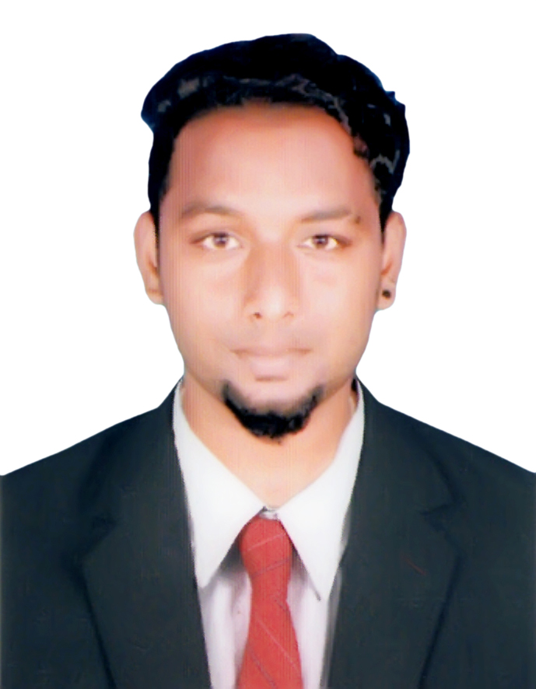

**To enhance & contribute the best of my learning, knowledge and experience to an esteemed organization. Looking to work with multiple responsibilities by sharing my skills/experience on competitive environment and to productively contribute towards the growth of the Organization and thus grow professionally.**

**R VIGNESHWARAN**

* Vickyravi6167@gmail.com

508463643

**Personal Profile**

Passport No : T3658062

Sex : Male

Nationality : Indian

Marital Status : Single

Religion : Hindu

Date of Birth :20/12/1998

**Technical Skills**

Photoshop, Design

MS Office, Word, Excel

Data Entry

**Linguistic Proficiency**

English (Read, Write & speak) Tamil( Read, Write & Speak)

Malayalam (Speak)

Hindi ( Speak)

Telegu ( Speak)

**Areas of Strengths** Good Team player

Photoshop Design Graphic Layout Self-confident Goal oriented Trust worthy

Good leadership quality.

**PROFESSIONAL EXPERIENCE**

**Company : TECHNICS MIDDLE EAST FZE IN UAE**

**Designation: MACHINE OPERATOR**

**Duration : APRIL 2019 TILL NOW**

**Company : COMSTAR AUTOMATIVE TECHNOLOGIES,**

**CHENNAI**

**Designation: QC ENGINEER**

**Duration :** 01-05-2017 to 05-12-2018

**Company : PHONEIX PHOTO LAB & GRAPHIC DESIGNING**

**Designation: PHOTO & GRAPHIC DESIGNER (Part Time)**

**Duration :** 01-04-2016 to 05-04-2017

**Roles And Responsibilities**

* Coordinating the office activities & managing other admin staffs.
* Experience in Construction Quality control.
* Actively participated in the Construction of new tanks in the refinery.
* Maintain effective relationship with office staff ,workes
* Experience in Construction Quality control.
* Good knowledge over various Non Destructive Testing methods conducted in a refinery
* Participated in fabrication & Erection of storage tank such as roof structure, tank shell, wind girder, etc.
* Witnessed various inspections for piping and tanks such as Radiography Inspection, Ultrasonic Testing, Magnetic particle Testing, Liquid penetrant testing, Hydrostatic testing, Pneumatic Testing, Flushing, Air blowing, Painting / Coating Inspection, Pig Cleaning etc.
* Experience in preparation of various reports for QC Documents such as Inspection and Test Plan, Fit-up/Weld visual, DP test, Material Inspection,

**EXECUTIVE COMPETENCIES**

* Team player and motivator with good interpersonal and communication skills.
* Spontaneous ability to adapt different working environments.
* Willingness to learn and cooperate with others, respect others thought and belief.
* Punctual, loyal, pious, flexible, eager to learn & take additional responsibilities in job
* Comfortable in a growing, high pressure fast pace environment.
* An ability to manage and work in a team and inspire team work.

**EDUCATIONAL QUALIFICATION**

|  |  |  |  |  |
| --- | --- | --- | --- | --- |
| **COURSE** | **NAME OF THE INSTITUTIONS** | **UNIVERSITY** | **YEAR OF PASSING** | **% OF MARKS** |
| Diploma in  DME | SINPC  Nagapattinam | Dote | 2017 | 70% |
| 10th Std. | Govt. Higher Secondary School,  Thirukanapuram | Tamilnadu Government | 2014 | 60% |

**EXPERIENCE**

1. Current Working TECHNICS MIDDLE EAST FZE IN UAE( VISA UPTO 2022)

2 Worked As Qc Engineer At COMSTAR PVT LTD CHENNAI From 01 -05-2017 To 05 -12-2018 1 ½ Years Experience

3 Worked As Graphic Designer & Photoshop Implement in Private Sector From 01-04-2016 to 05-04-2017 1 Year Experience

**WORK UNDERTAKEN**

* Lead in Photoshop, Designing implementation
* Data Entry
* Ultrasonic Testing
* Penetrant Testing
* Magnetic Testing
* Visual Testing

**DECLARATION**

I hereby declared that the information furnished above is true to the best of my knowledge and belief. Assuring utmost faithfulness and dedication in work assigned, if selected

Date :

Place : Dubai **R VIGNESHWARAN**