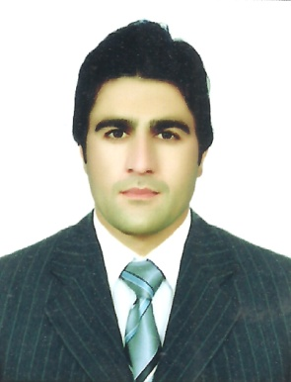**Curriculum Vitae**

# IRFAN ULLAH

**Contact Mobile :0557282245**

**E-mail: irfanullah0751@gmail.com**

**OBJECTIVE:**

To be associated with an organization, that provides career development opportunities so that I may contribute in its progress through the best of my knowledge and skills.

**PERSONEL INFORMATION;**

* Father Name: Subhan Ullah
* D.O.B: 16-05-1993
* Religion: Islam
* Nationality: Pakistani
* CNIC: 15306-3380080-9
* Visa status visit visa

**PROFESSIONAL EXPERIENCES:**

* Accurately record and enter results into electronic medical record system for physician.
* Report unexpected or unusual results to supervisor for further analysis.
* Maintain clean and sterile work environment, following all applicable safety protocols.
* Test laboratory equipment to ensure accuracy and consistency; troubleshoot any malfunctioning equipment
* Investigated atypical results and discrepancies to determine causation.
  + Prepared chemical solutions, reagents and specimens for microscopic examination.
  + Performed quality control and calibration on many analyzers:.
  + Analyze various samples that come in for chemical testing and generate the relevant reports
  + Maintain over-all quality control in the medical lab
  + Ensuring sample collection in properly sterilized containers and maintain analysis instruments functional and up to date
  + Post and record full day’s record in the medical lab software before closing up each day
  + Implement and maintain standard medical lab policy guidelines in the lab
* Obtained blood samples for medical testing and transfusion.

**Work History**

**Lab Technician:**

* 2 months experience is a phlebotomist covid-19 at thumbay hospital fujirah.
* City Diagnostic Lab & Research centre Timergara Dir Lower KPK 01-07-2015 to 01-10-2019.
* Two Year Experience In the Department of Pathology in DHQ Hospital Timergara Dir Lower KPK Pakistan.

**Areas Of Expertise**

|  |  |  |  |
| --- | --- | --- | --- |
| Hematology | Immunology | Blood Banking | Microbiology |
| Chemistry | Serology | **Phlebotomy** |  |

**WORKING EXPERIENCE WITH DIFFERENT MACHINES:**

* Selctra-E Chemistry Analyzer • Immulite-1 Plus
* Cobas-C 311 • Micro lab 200 & 300
* Cell DYN-Ruby • Mindray BC-5000

**TECHNICAL SKILLS**:

* Knowledgeable in medical laboratory testing
* Proficient with patient sampling
* Certified medical laboratory technician
* PC Software Application
* MS. OFFICE, World, Excel
* Internet & E-mail

**EDUCATION:**

* Two Years Diploma in Pathology (Laboratory Technology) From Peshawar Medical Faculty KPK.
* SSC From B.I.S.E Malakand KPK.
* F.A From B.I.S.E Malakand KPK.
* Bachelor Degree in Social Science From University of Malakand KPK.
* Master in Islamiyat (M.A) from University of Malakand KPK.

**COMPUTER SKILLS**

* One year diploma in information technology (D.I.T) from trade testing board Peshawar KPK Pakistan
* Six months Certificate in information technology (C.I.T) from trade testing board Peshawar KPK Pakistan