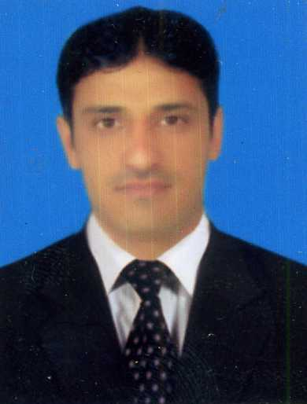
Curriculum Vitae
Syed Danish Ali Naqvi
Nationality: Pakistani
Email: naqvinaqvi758@gmail.com
Contact No: +971568841265
WhatsApp No: +923459585758
Country of stay: UAE
CAREER OBJECTIVES:
My experience and skills can be put together to achieve the goal of the organization maximum deduction to improve the status and profitability of the organization.
Work experience:
More than 6 years of professional experience
Accountant:
Junaid Medical Hall & Wholesale Distributors.(Muzaffarabad Azad Kashmir)
From: 10-02-2016 to still continue…
Duties & Responsibilities
- Purchase invoices i-e (adding products into company accounting software which are purchased from different vendors)
- Purchase return i-e(Brk/Exp/Normal)
- Making Retail bills
- Prepair invoices i-e (Warrenty/Non warrenty bill)
- Customer ledgers/outstandings
- Finincal statement of all customers
- Sale/stock drawing reports i-e(Town/Area wise)
- Sales/stock drawing reports i-e(Daily/Weekly/Monthly/Yearly)
- Generate finincal statement i-e(Profit & loss)
Data Entry Operator:
Metropolition International School & College
From: 25-06-2013 to 10-08-2015
Duties & responsibilities

- Entering data from various sources into company computer for processing and management
- Sending & receiving Emails
- Entering data into computer software and checking to ensure the accuracy of data that has been inputted
- Transfers information from paper formats into computer file using (keyboards, data records or optical scanner)
- Perform regular backup to ensure data preservation
- Labeling the files & Responding to information request from authorized members
- Maintain a filling system and protect confidential information
Sale Representative:
State Life Insurance Corporation Of Pakistan. (Muzaffarabad Azad Kashmir)
From: 28-02-2011 to 28-02-2012
Duties& responsibilities
- To have excellent knowledge of various product of insurance
- To be responsible for collecting the necessary document such as age proof, ID proof , and so on
- Analyze current insurance policies of clients and suggest changes or additions
- Explain the features of different policies and planes
- Provides death benefits by delivering policy proceeds and reassessing client needs
- Interview prospective customer to discuss their existing coverage
- Get financial resource of the client
- To help underwriter in assessing risk, to help clients to make any changes and help legal beneficiaries for claims settlement

Revelent skills:
Electronic data processing knowledge:
Excellent in Microsoft office program:
Ms Word: excellent skills in editing typing and maintaining documents.
Ms Excel: professionally trained in using Ms Excel skills, Excellent skills to create and maintain Excel sheet on daily basis.
Powerpoint Presentation: Extra ordinary skills in creating powerpoint presentaions excellent presentation skills.
Softwares:
ACCOUNTING SOFTWARE TALLY .ERP9
- Company Creation/Editing/Deleting
- Good knowledge of journal, ledger, trail balance, income statement/Balance sheet
- Voucher Enteries i-e Contra, Jouranl, Sale, Purchase etc According to Dr/Cr Rules
- Ledger Creation/Editing/ Deleting
- Group Selecton During Journal Enteries
- Vat Implementations
- Adjustment Enteries i-e Outstanding,Prepaid Expenses Accured Incom,Unearned Incom,Deprecation

EDUCATIONAL BACKGROUND:

Bachelor Of Science(B.Sc.)
University Of Azad Jummu & Kashmir Muzaffarabad AK.
Passing year: 25-10-2010
Intermediate
BISE Of Mirpur Azad Jummu & Kashmir.
Passing year: 11-09-2007
SSC:
BISE Of Mirpur Azad Jummu & Kashmir.
Passing year: 09-12-2004
PERSONAL INFORMATION:
Full Name : Syed Danish Ali Naqvi
Father Name : Syed Sabir Hussian Naqvi
Material Status: single
Date Of Birth: july 02-1988
Place Of Birth : MUZAFFRABAD AK
CNIC: 82203-8851430-9
Passport : AT9394302
Relevant Qualifications:
Languages:
English: fluent in speaking and writing
Urdu: Mother language
References: Will be provided on demand
I do hereby declare that all above mentioned information is correct.

