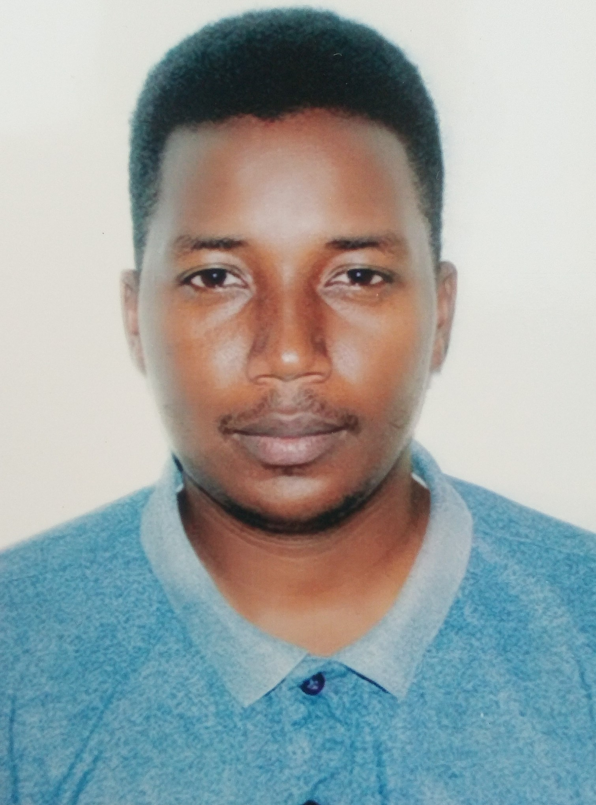  Personal Profile  Name : ABRAHAM KIZZA  Sex: MALE  Nationality: Ugandan  Visa : Visit Visa  Phone  +971 559868442  Email address:  abrahamkizza@gmail.com  Languages  - English  Referees  Available upon request | Curriculum Vitae
 | Career Objective
 | Secure a responsible career opportunity to fully utilize my training and skills, while making a significant contribution to the success of the company.
 | Educational Background
- Dip. Business Administration
- A level certificate
- O level certificate

 | Professional Development
- Communication skills (customer handling)
- Team Player
- Record Keeping

 | Work Experience
CUSTOMER RETAIL SALES REPRESENTATIVE ,AFRICEL TELECOM CO, UGANDA, 2 YEARS
Responsibilities;
- Attend to all walk - in- customers by greeting them and finding out how they need to be helped
- Solving customer queries at first contact and escalating in case issue needs to be solved at another level
- Receiving calls from customers and answering them and solving their queries in the most appropriate way
- Making out bound calls to new customers, welcoming them to the network and making them feel comfortable.
- Updating all customer information in the system as I interact with them either physically or on call.
- Cross selling and upselling Africell products including internet data plans, Handsets, Routers, call plans etc
- Participating in keeping the service centre tidy and decorated when need be and doing any other assignment given by my supervisor

CUSTOMER CARE OFFICER-CREDIT,SOLANTIS SOLAR COMPANY 1year
Responsibilities
- Evaluate client’s creditworthiness and risks, analyze risks and approve or reject credit sales request
- Create credit scoring models to predict risks ,pay attention to details of individual clients and follow tracts of customer payment
- Calculate and set interest rates
- Review and update credit files
- Review credit sales agreements to ensure that they are complete and accurate and have been done according to policy.
- Negotiate credit and payment terms with customers
- Monitor payments of credit customers
- Maintain an updated record of all credit sales
- Follow up with clients to manage debt settlements, exercise good communication skills and customer care when it comes to approaching delinquent clients
- Regularly contact clients to gather financial data and documentation
- Ensure all credit procedures comply with company regulations
CUSTOMER CARE EXECUTIVE ORANGE TELECOM, UGANDA, 1 YEAR
Responsibilities;

 | .
 | Computer skills:
- Microsoft office word, Excel
- Internet browsing and Emails
 | Competences
- Customer service
- Product knowledge
- Quality focus
- Market knowledge
- Documentation skills
- Listening skills
- Phone skills
- Conflict resolution
- Multitasking
- Patience
- Negotiation
- Positive attitude
- Attention to detail

 | Hobbies
 | Making friends, Swimming, Reading over internet and sports, Listening to music

