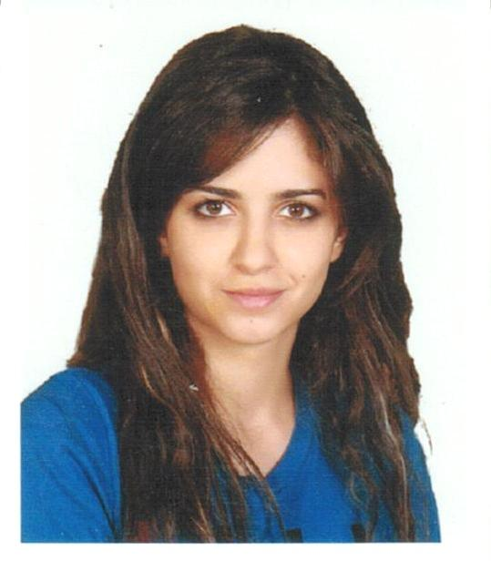

Curriculum Vitae of

**DANA EMAD ALBOUAINI**

T. : +971 50 2626422

M.: [Dana.albouaini@gmail.com](mailto:Dana.albouaini@gmail.com)

**OBJECTIVE**

To play a successful part in a progressive organization that allows me to develop my knowledge and skills in accordance with it’s goals and vision, and to be part of team that dynamically works towards growth of the organization.

**PERSONAL DETAILS**

Nationality : Syrian

Date of Birth : 8-7-1989

City : Abu Dhabi, UAE

Civil Status : Married

Visa : Family Visa – Valid

Driving License : Yes

* Proud to be self motivated in all aspects of personal and professional life.
* Capable of making a hard task easier using problem solving & negotiation skills.
* Planning to add to the organisation my youthful soul, energy & enthusiasm.

**EDUCATION**

* **MBA degree 2016 - Wolverhampton University, UK**
* **BACHELOR in Marketing to Management 2012** - **Abu Dhabi University, UAE**
* **CEPA, IELTS 2018- Average 7.5, IBT Certificates**
* **SEO and Digital Marketing Training 2020 - British Columbia International Academy.**
* **Google AdWords Certification 2020- Google**

**WORK EXPERIENCES**

**Communications Manager**

Flash Entertainment

October 2019 till March 2020

This work included the responsibility for a wide range of tasks and deliverables relating to communications for FLASH (corporate) and projects/events.

Responsible for:

* Assigned communication staff
* Assigned temporary staff
* Contract management of third party suppliers

Functional Role:

* Collaborate with marketing team to ensure ‘objective’ based campaign development and tacitly integrated communications.
* Develop and manage fully integrated communication plans.
* Prepare and write press releases and develop messaging matrix.
* Develop feature ideas and schedules.
* Develop and maintain media relationships.
* Ensure buy in of features sell-in by all media targets.
* Prepare and manage event communication plan and delivery.
* Undertake and evaluation and accurate reporting of all communication activities (corporate and projects).
* Develop and implement a partner outreach program focused on key Abu Dhabi companies.
* Coordinate and strengthen relationships with external partners.
* Prepare and deliver speeches, on-camera and phone interviews with media.
* Establish new direct relationships with local, regional and international media.
* Develop strong relationship with artist management and publicist at the onset of the project.
* Provide input, based on research and experience, into the creative process and ensure that potential ideas and concepts are captured and assigned accordingly.
* Undertake research around communications.
* Effectively communicate campaigns expectations to event team members, other FLASH departments, third parties and stakeholders in a timely and clear fashion.
* Estimate the resources and participants needed to achieve communication goals (Consult, if part of a program of events, with the Project Manager on the allocation).
* Draft and submit budget proposals, and recommend subsequent budget changes where necessary (Consult, if part of a program of events, with the Project Manager on the impact).
* Liaise with and seek written approval from the Artists Management for all communication material including any ongoing updates, amendments or additions, prior to the commencement of any campaign for each project.
* If required, seek the assistance of Talent Management and Projects in the organization of the press conferences, artist appearances, and other media activity that incorporates company executives and / or artist appearances for each project.
* Support Vice President Marketing & Communications in new Strategic Initiatives.
* Identify and manage dependencies and critical path.
* Responsible for developing a detailed and comprehensive PR plan with associated communications documents for the project/event including detailed work breakdown structures.
* Comply and follow process according to current FLASH standards including compliance procedures and event forms.
* Ensure that Value In Kind (VIK) is valued, recorded and adopt a recording process that is compliant to accounting standards (Auditor approved).
* Successfully define and quantify tasks and deliver on time and to quality requirements.
* Set and continually manage expectations with team members, departments and other stakeholders.
* Represent the company as the Spokesperson.
* Delegate tasks and responsibilities to appropriate personnel in various departments and specialist roles.
* Provide weekly update to Project Manager on the status of contracts, LPOS and invoices (pending, awarded, paid, accruals).
* Develop and deliver progress reports, proposals, requirements documentation and presentations including monthly management and board reports (Consult, if part of a program of events, with the Project Manager).
* Proactively manage changes in project scope, identify potential crises, and devise contingency plans using risk management standards.
* Coach, mentor, motivate and supervise communication team members and contractors, and influence them to take positive action and accountability for their assigned work.
* Build, develop, and grow any business relationships vital to the success of the project
* Prepare and present communication evaluation reports and creates a recommendations report in order to identify successful and unsuccessful project elements (Consult, if part of a program of events, with the Project Manager on the impact).
* Develop a mechanism to initiate proposed communication improvements in terms of process, deliverables, etc. for each project/event (Consult, if part of a program of events, with the Project Manager on the impact).
* Develop best practices and tools for communication execution and management (Consult, if part of a program of events, with the Project Manager on the impact).

## **Sr. Account Manager**

## Ali & Sons - IQ Experience

## January 2016 till December 2018

Functional Role:

* Preparing IQ’s yearly Action plan, that includes budgeting, hiring, staff training and business development
* Managing the Motors marketing accounts including: Porsche, Audi, VW and Skoda. Tasks include:
* Event Management: where our team helped in planning and executing more than 15 events throughout the 3 years, our duties included:
  + Planning the events Budget
  + Coordinating with the third party suppliers and partners
  + Preparing & Managing the event’s Timeline
  + Following up closely to keep all activities in check
  + Crisis management and handling changes professionally
  + Preparing the event’s Marketing campaigns and PR
  + Managing tasks and following up to deliver on time as scheduled
  + Collecting and maintaining the marketing database

Events including

* + - * New showrooms openings
      * New car models launches
      * 911 Club Sport racing competitions
      * Football tournaments
      * Ramadan Tents ..etc
* Preparing the marking budget for each brand
* Managing the Marketing campaigns starting from planning to execution including:
  + - ATL Campaigns:
      * Radio, Print Media (Newspapers, Magazines)
    - BTL Campaigns:
      * Direct Mail Marketing
      * Sponsorships
      * Targeted search engine Marketing
      * Brand Activations
      * Production material: Window stickers/Flyers/Brochures ETC
    - Online campaigns:
      * Digital Marketing & Social media
* Involved in helping ( Amwaj Jewelry shop, Awazin Medical Center, Euro Star Rent A car and Ali & Sons Oil and gas) executing their Marketing plan
* Managing the creative team (Designer and Copywriter) and proof reading the material before publishing.

## **Business Development Manager** Tarweej International Media October 2013 - June 2014 ( 9 months)

Functional Role:

-Developing and executing short/Long-term marketing plans.   
- Hiring and training the sales team.   
- Supervising and directing the designers and creative team.   
- Meeting with the new and existing clients, helping in maintaining a strong prosperous relationship

**Business Developmnet Manager**

FissionLink for Social Media Marketing

May 2012 - November 2013 (19 months)

Functional Role:

- Establishing relationships with our clients and maintaining them with good communication

- Hiring, Supervising and Training our sales Team

- Planning our Social Media events.

**Account manager**

**Gravity IT Solutions**

Year 2010-2012 (18 months)

Functional Role:

- Establishing relationships with our clients and maintaining them with good communication

- Hiring, Supervising and Training our sales Team

- Planning our Social Media events.

**Sales Consultant at (Reed Exhibition)**

TwoFour54

Year 2010(2 months)

Functional Role:

* Responsible for calling interested companies (C level managers) to inform them about WFES 2013 (World Future Energy Summit).
* Working under stress where tight target has to be attained in a short period of time.

**Facilities Intern**

CfBT Trust - University Internship

Year 2010 (4 months)

**LANGUAGES**

* Arabic - Mother Tongue
* English – Fluent in reading, writing and speaking

**COMPUTER SKILLS**

* Windows XP - MAC
* MS Office (MS-Word, MS-Excel,MS-Power Point)

**ABILITIES**

* Hard worker & well organized
* Creative and life-long learner, diplomatic, patient, team player and cooperative.
* Performing well under pressure
* Detail-oriented, multi-tasked, balances priorities and day-to-day activities and deadlines.
* Proactive and take initiative
* Very responsible, dependable and hard worker with full willingness to undertake new tasks.
* Interpersonal & presentation skills
* Possess analytical skills and resourcefulness
* Looking and acting professional at all time

**SKILLS**

* Strong communication skills and in-depth understanding of events and media industry.
* Working in a matrix environment requires a strong communicator with excellent influencing, negotiation and relationship building skills.
* Motivate and manage the communication to deliver on time, budget and at the required standard of quality.
* Skilled in coordinating flow of information and communication between staff, consultants and senior management, with the ability to effectively manage time and work to meet deadlines.
* Strong oral and written communication skills (including the ability to draft understandable, clear and consistent documents on topics within the areas of responsibility).
* Will have a high degree of integrity and a high sense of personal and professional ethics.
* Ability to consider and advice on the consequences of various courses of action, including an understanding of the repercussions on other activities.
* Ability to engender confidence of management and exercise good judgment in handling sensitive information.
* Ability to manage multiple tasks, organize priorities and meet deadlines.
* Detailed attention to quality of deliverables.
* Desire and ability to demonstrated initiative.
* Strong attention to detail, by being thorough and responsible.
* Ability to proofread and review accurately (Prepare and review copies, marketing collateral, contracts, etc.).
* Excellent process skills, analyze and standardize workflows.
* High level of stress tolerance.
* Excellent negotiation skills by being assertive and respectful.

**REFERENCES**

* Avalable upon request.