***ISSAM ELALAOUI ELGHABBAR***

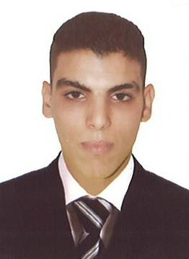

***Address***: 1504 Charie Nasr

Sharjah , UAE

***E-mail:*** issamelghabbar04@gmail.com

***Phone:*** 050 387 9364

***WORK EXPERIENCE:***

Foot Locker Dec 2013 — Oct 2015

NIKE Factory Store Dec 2011 — Oct 2013

Polo Ralph Lauren Dec 2009 — Nov 2011

***Sales Associate***

. Attending to all customers need and satisfaction at all time.. Responsible in

maintaining a clean,order and good display.

. Reporting to supervisor of the result of the daily sales.

. Ensuring that stocks are sufficient enough for the day-to-day sales as per demand.

. Greeting and serving customers.

. Having a keen awareness of store merchandising.

. Keeping the store tidy.

. Responding to any customers concerns.

. Other duties as assigned by manager.

. Inventories supplies and equipment at end of each voyage.

***Sales Associate***

. Attending to all customers need and satisfaction at all time.. Responsible in

maintaining a clean,order and good display.

. Reporting to supervisor of the result of the daily sales.

. Ensuring that stocks are sufficient enough for the day-to-day sales as per demand.

. Greeting and serving customers.

. Having a keen awareness of store merchandising.

. Keeping the store tidy.

. Responding to any customers concerns.

. Other duties as assigned by manager.

. Inventories supplies and equipment at end of each voyage.

***Assistant Manager***

Any job I do have experience and I am fast learning and my job responsibilitie was to

make sure that the customers happy and keep everything clean and fresh and

opening/closing also I used to go to the bank to deposit the money and check the

computer system if there is any problem.

***QUALIFICATIONS***:

High School Diploma

EDUCATION Life and Earth Sciences 2009 — 2010

Al – Farabi

Earth Science is the study of the Earth and its neighbors in space. It is an exciting

science with many interesting and practical applications. Some Earth scientists use their

knowledge of the Earth to locate and develop energy and mineral resources. Others

study the impact of human activity on Earth's environment and design methods to

protect the planet. Some use their knowledge about Earth processes such as volcanoes,

earthquakes and hurricanes to plan communities that will not expose people to these

dangerous events.

***REFERENCES:***

**Anas: Friend 97156 8 98 190 5**

**Mouhssine: Cousin** **97150 17298 8 8**

***SKILLS***:

Attention to detail.

Punctual and reliable.

Can work Over time.

Ability to cope and work under pressure.

Good written and verbal communication skills.

Able to work as part of a team.

Having a patient outlook.

Ability to multitask and manage conflicting demands.

Ability to prioritise tasks.

***PERSONAL ABILITIES:***

.Sociable personality.

.Team player.

.Self motivated.

.Creative.

.Responsible.

.Dedicated.

.High levels of integrity.

.Loyalty.

***LANGUAGES:***

#Arabic.

#Moroccan.

#English.

#French.

#Spanish.