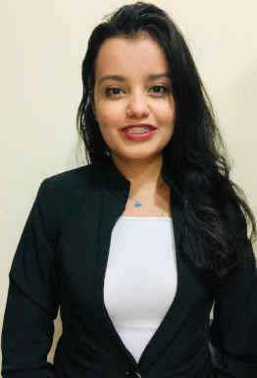
MANAR HOSNEY

ABU DHABI, United Arab Emirates
+971 527294515
MANAR.ATA.MOHAMED@GMAIL.COM
Company VISA

SUMMARY

Office ADMINSTIRATOR / Receptionist
ARABIC/English

With experience in office administrative and events organizing, I have gained a comprehensive understanding of work roles management. I have proven relationship skills and ability to build-up fruitful partnerships and possess the requisite drive and determination to work unsupervised. My self-motivation, persistence and openness have resulted in positive feedback in each of my successive job roles and helped me gain recognition and acquire more responsibilities throughout my career.

Field | Skillset | Expertise | Details
Learning & Development | MANAGE STRESS , SET GOALS ,TIME MANAGEMENT Workshops delivery |  | - 4 years of experience  COLLEGE HEAD TEAM FOR EVENTS AND TRAINING.
Sales Tools | COMMUNICATION , TRAINING , KPIS,TARGET |  | - 2 years of experience  18 months Omar toys company for education and early learning goods.  6 months Levi’s ADM.
EVENTS PLANNING | ORGANIZING,BRIEFING ,TAKING NOTES , |  | 3 MONTHS EXPERINCE

EXPERIENCE

► OFFICE ADMINSTIRATOR / RECEPTIONIST – GDMCC
ABU DHABI – United Arab Emirates / JANURAY 2020 to present
My current role is to manage doctors’ appointments through:
•Created and confirming daily agenda.
•Dealing with insurance companies for approvals.
•Follow-up, mails, calls and receiving feedback.
•Track progress with Opportunity management Tool and discussing the results with the admins every month through reports.
► Sales executive, Levi’s ADM
ABU DHABI – United Arab Emirates / JULY 2019 to JANURAY 2020
I was responsible for assisting our customers to deliver %100 customer satisfaction.
O Customer Service Experience workshops – conducted 22 workshops.
O Daily financial reports.
O Achieving targets and kpi.

Results:
➔ Won Award for Performance Excellence in customer service with mystery shopper when I was still under preparations period.

►pr and oc assistant at Alexandria book fair
February 2016 to July 2017
•organizing everyday meeting.
Handled visitors inquiries from quotation to booking including events time table , rooms organizing , follow-up on deliveries from suppliers, hotels and flight ticket booking for VIP visitors , inbox handling, , maintenance units .
Attended daily visitors calls and occasionally joined face to face team meetings .

Customer service representative – new horizon
Alexandria-Egypt / January 2016 to February 2017,
Provides service supply for customer in the telecommunications sector. My role was to redirect calls, mails to the concern department, register complains to get the concern department.
- Prospected and sought new customers
  - Analyzed customer needs
  - Estimated contributions for customers when subscribing

EDUCATION & TRAINING

Bachelor degree of mass communication department
Faculty of arts, Alexandria University, pr and advertising sector. MAY, 2019
CGPA: 2.9

- COURSES AND TRAINING :-
ICDL
ORACLE
LEADER SHIP
COPYWRITING

