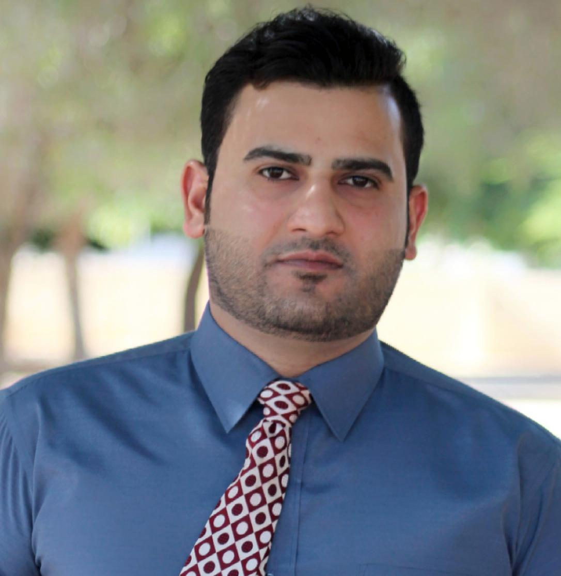

**Irfan Ahmad**

Resident in Dubai, UAE)

Email: raj1988rajput@gmail.com

Mobile # **+971 564732133**

**CAREER OBJECTIVE**

Sales Associate with 5 years of experience in retail environments. Recognized for ability to communicate with customers, providing exceptional service that ensure client retention and positive feedback. Proven ability to increase sales through upselling techniques as well as implementing processes that drive profitability.

**.Professional experience.**

* **( 1)Company: Axiom telecom dubai**
* **Period. 2016 to 2018**
* **(2) company Merilex marketing management online trading dubai**
* **Period. 2018 to 2020**
* **(3) company. Dirham mobile and computer store LLC .Ajman**
* **Period. 2020 to 2021**
* Assist an average of maximum customers per day in finding or selecting items, and provided recommendations that generated maximum in additional revenue
* Stock, replenish, and organize inventory with accuracy and efficiency, completing function 10% faster than average associate
* Achieve an average of maximum of sales goals for three consecutive months
* Manage proper and attractive merchandise display, ensuring strategic placement of products that maximized purchases
* Provide outstanding customer service, receiving 100% in customer service feedback surveys
* **Targets in axiom 2016 till 2018**
* **Target in merilex market management 2019 to 2020**

Helped an average of 50 customers per day by responding to inquiries and finding products,Recommended better merchandise display to management, which was implemented and resulted in 35% improved sale’s--Assisted team members when necessary in handling cash registers, organizing inventory room, labeling products, unloading merchandise, and cleaning up-Aided Spanish-speaking customers, increasing repeat and loyal customers by maximum of quantity

**ACTIVITIES**

* Very polite and helping nature.
* Excellent communication.
* Knowledge of customer services and communication skills verbal & written.
* Ability to easily communicate with customers.
* Excellent time management skills.
* Able to follow instructions on daily project’s and procedure.
* Good problem-solving skills.
* Strong interpersonal.
* Dynamic enthusiastic & creative individual.
* Able to Work under pressure & meet Deadlines

**EDUCATION** and **CERTIFICATES**

* **Post graduation** of Indus university karachi pakistan
* **Diploma of Electronics**

Government technology college Karachi Pakistan

**YEAR of Achieving**

2010-2012

**.PERSONAL information**

D.O.B : 15_01_1988

Height : 5:7 inch

Religion : Islam

Nationality : Pakistan

Languages : English, Arabic,Urdu,hindi,

Status : Married

Visa status : resident visa