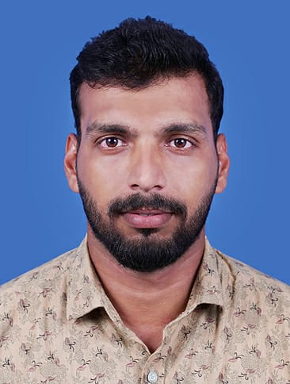
FABID. N.A
NELLI VEETTIL HOUSE
CHULLIPARAMBA
FAROOK COLLEGE POST
KOZHIKODE (DT)
KERALA
INDIA
PIN 673632
Passport no: U7841598
Date of Birth: 1 October 1988
Email: fabidattupuram@live.com  Mob:+919846316965

An enthusiastic Engineering professional aspiring for a career in a growth oriented organization which provides me avenues for learning and implementing acquired skills and knowledge in achieving organizational goals, while attaining personal and professional growth.

Profile at a Glance

- A self-motivated individual with strong analytical mind-set to learn quickly, to analyze the situation, identify requirements and provide solutions.
- Hard working and goal-oriented, with a high degree of flexibility, resourcefulness and commitment.
- A dedicated and diligent team player, with high adaptability.
- Excellent communication and presentation skills.
- High competitive self starter, who is organized, disciplined.

Professional Experience

- Business in Oman
Duration: December 2015 till date

- Kairali TV, Malayalam Communication Ltd,Thiruvanandapuram (www.kairalitv.in)
Duration: From December 2011 to October 2015 (4 years)
Designation: BROADCAST EDITOR (Kairali TV Play Out)

- Kearala Vision, Kerala Communicators Cable Ltd, Thrissur (www.kccl.tv)
Duration: From October 2010 to 2011 (1 year)
Designation: PLAYOUT ADMINISTRATOR

Technical Experience
- Network Switch
Cisco 500 Series, Cisco 3560

- Video Encoder
Optibase, Thomson,
- Video Switchers
Sony DFS 700, Panasonic MX-70, Data Video System, Kramers Switch

USED SERVER

SI MEDIA AUTOMATION, GRASSVALLEY K2 SUMMIT, PLAY BOX, C CHANGE.

Skills
Technical skills
- Windows 2000/Xp, 7, 8, 10 Installing, configuring, Trouble Shooting
- LAN Networking & Trouble Shooting
- Managing FTP site for News
- Live Telecasting using Fiber Media with bandwidth control
- Managing Optical Fiber Networks & Media converters

Educational Qualifications
Course | Board/ Institution | Year
Diploma in Computer Engineering | Dept. Of Technical Education | 2006-2009
Plus Two | HSE Kerala | 2004-2006
SSLC | Kerala Board of Examination | 2003-2004

Linguistic proficiency

English, Malayalam and Hindi

Reference

K.R.Suresh,
Deputy General Manager (Systems),
Malayalam Communications Ltd.
Mob: 919846051024

Gijesh Raman,
Solution Architect (South India Operations),
Beijing Novel Super Television.
Mob: 919740559944

