**BIODATA**

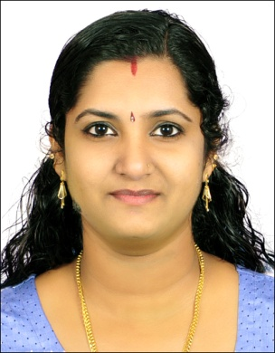

**JISHITHA A J**

**ALAPPATTU HOUSE**

**KUDAYATHOOR P O KOLAPRA**

**IDUKKI, KERALA. PIN 685590**

**MOBILE NO: 9562946414**

**EMAIL ID _: jishitha1990@gmail.com**

**PERSONAL INFORMATION**

**PRESENT ADDRESS : ALAPPATTU HOUSE**

**THODUPUZHA EAST P O**

**KARIKODE**

**685585**

**FATHER NAME : A N JANARDHANAN**

**DATE OF BIRTH : 18/03/1990**

**GENDER : FEMALE**

**NATIONALITY : INDIAN**

**MARTIAL STATUS : MARRIED**

**RELIGION : HINDU**

**LANGUAGE KNOWN : MALAYALAM, ENGLISH**

**EDUCATIONAL QUALIFICATION**

* **S S L C**
* **PLUS TWO**
* **BA (HISTORY)**

**ADDITONAL QUALIFICATION**

**M S OFFICE**

**EXCELL**

**EXPERIENCE**

**. 1 YEAR EXPERIENCE IN GEO GAS AGENCY AS CLERICAL STAFF AT THODUPUZHA TO 2012-2013.**

**. 2YEAR EXPERIENCE IN PYNADATHU EDU WORLD AS RECEPTIONIT AT THODUPUZHA 2013-2015.**

**. 3 YEAR EXPERIENCE IN GEO GAS AGENCY AS CIERICAL STAFF AT THODUPUZHA 2016-2019.**

**. STILL WORKED AT INDUS MOTORS LCV (P) LTD THODUPUZHA AT CUSTOMER RELATIONSHIP EXECUTIVE**

**DECLARATION**

**I JISHITHA A J, here by confirm that the information given in this form is true to do the best of my knowledge and information.**

**PLACE : THODUPUZHA DATE : 13.05.2022 JISHITHA A J**