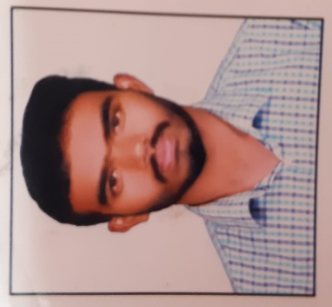  Contact. No:  +91 9562097016  Favufavas3@gmail.com  Personal Data  Adderess:  elambilavil (Ho)  karayad(Po)  Meppayur(Via)  Kozhikode(Dis)  Kerala,673524  Date of Birth:  12-05-1999  Gender:  Male  Father’s Name:  Rafeeque  Nationality:  Indian  Marital Status:  Single  Languages Known: English, Tamil & Malayalam | Curriculum vitae  FAVAS E T  OBJECTIVE  Secure a responsible career opportunity to fully utilize my training and skills, while making a significant contribution to the success of the company.  Education Qualification  Qualification Institute/University Year of Pass %  Bcom computer application SILVER ARTS AND SCIENCE COLLAGE,PERAMBRA ,Calicut University 2020 60  Plus Two KPMSMHSS Arikkulam 2017 76  SSLC NHSS Nochad 2015 76  Academic Project  - A study on CUSTOMER SATISFACTION ON YAMAHA TWO WHEELERS IN ARIKKULAM PANCHAYATH(under Calicut university)  Technical Skills /computer proficiency  - MS EXCEL  - MS PowerPoint  - MS word  Abilities  - Honest and exhibits integrity at work.  - Confident to fulfill tasks efficiently and effectively.  - Enthusiastic and a team player.  - Positive approach.  - Adaptable.
Experience
- North link business group Marketing executive(2 month)
- Ruchy online chappathi sales executive (3 month)

Languages Known

- English
- Malayalam
- Tamil

Declaration
I hereby declare that all the information mentioned above is true the best of my knowledge

FAVAS E T

