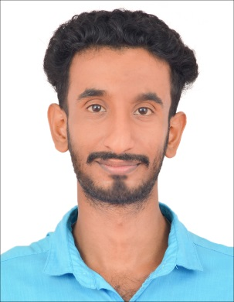

**BIPIN.KOSHY**

**Contact Number:** **+971 544639823, + 971 588531477**

**What’s App Number - +919061545558**

**Email ID: bipinkoshy1995@gmail.com**

**Passport Number: N9778623**



**CAREER OBJECTIVE**

**Looking for an opportunity with an organization for achievement of long term goals which empower the freedom to expand my mind laterally and career vertically, thus contributing to the growth of the organization and grow consequently.**

**Educational Qualification**

|  |  |  |  |
| --- | --- | --- | --- |
| **Course** | **Year of**  **Passing** | **Institution** | **Board/**  **University** |
| Class X | 2011 | SREE VIJAYESWARI, CHERIANAD | SSLC |
| PLUS TWO | 2013 | G.H.S.S ALA | BOARD OF HIGHER SECONDARY EXAMINATION |
| B.COM | 2016 | SERT IT CAMPUS,CHENGANNUR | M.G.UNIVERSITY, KOTTAYAM |
| HVAC | 2016 | ROYAL INSTITUTE OF COCHIN | MINISTRY OF SKILL DEVELOPMENT & ENTREPRENEURSHIP |

**strengths**

* **Dedicated and hardworking**
* **Ability to work under pressure and through long hours**
* **Certified HVAC Technician including refrigerant handling.**
* **Efficient worker; can complete work and related tasks within a reasonable time frame.**

**main responsibilities**

* **Attending AC Technical Problems In The Field**
* **Attending Complaint At Site**
* **Repairing Of AC Related Jobs**
* **Checking And Repairing Air Condition**
* **Worked As Electrician And Plumbing (Cutting,Wiring,DC And Other Small Problems)**

**WORK EXPERIENCE**

**SALES MAN & CASHIER - ARAFA RESTAURANT & WILSON TIMES (2015 – 2017)**

**HVAC TECHNICIAN - COMFORT COOLING SOLUTION KOCHI (2017-2018)**

**CHILLER PLANT TECHNICIAN - CENTER SQUARE MALL COCHIN**

**HVAC TECHNICIAN - AL MEMZAR CONTRACTING LLC (2018-PRESENT)**

**hobbies**

* **Reading**
* **Listening Music**
* **Travelling and Playing**

**personal profile**

* **Name : Bipin.Koshy**
* **Father’s Name : Monachan Koshy**
* **Religion : Christian, Orthodox**
* **Marital Status : Single**
* **Date of Birthm : 06-03-1995**
* **Languages Known : English, Malayalam, Hindi,Tamil**
* **License : UAE Manual Driving License**
* **Address : Mulakkithara Thundiyil,**

**Perissery P.O,Chengannur**

**Alappuzha**

**PIN-689126**

**declaration**

**I hereby confirm that all the information furnished by me is true to the best of my knowledge and belief.**

**Place:**

**Date:**

**Bipin Koshy**