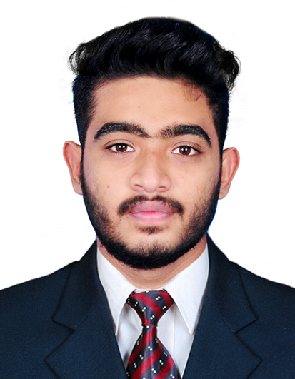

PHOTO
CURRICULUM VITAE

PROFILE
Name Date of Birth Gender
MUHAMMED RAZIN 13/12/1999 Male

Language Marital Status Nationality

Malayalam, English & Hindi Single Indian

Father’s name : NIZAR.PP
CONTACT ME
Permanent Address Mobile Number
Al Reffa Building, Bur Dubai +971 508387703
Dubai,
United Arab Emirates
EDUCATIONAL QUALIFICATIONS
- Plus Two, Kerala Board of Higher Secondary Examinations, Kerala
- SSLC, Board of Public Examination Kerala
PROFESSIONAL QUALIFICATIONS
- Certificate in Graphic Designing, Mac Tec- Kerala.
SKILLS
- Good Communication
- Computer Skills
- Windows ,MS Office Skills
- Personal Integrity
- Commitment to deadlines
- Attention in Details

DECLARATION

I hereby declare that the above particulars are true and correct to the best of my knowledge and belief.
Place : DUBAI
Date : MUHAMMED RAZIN

