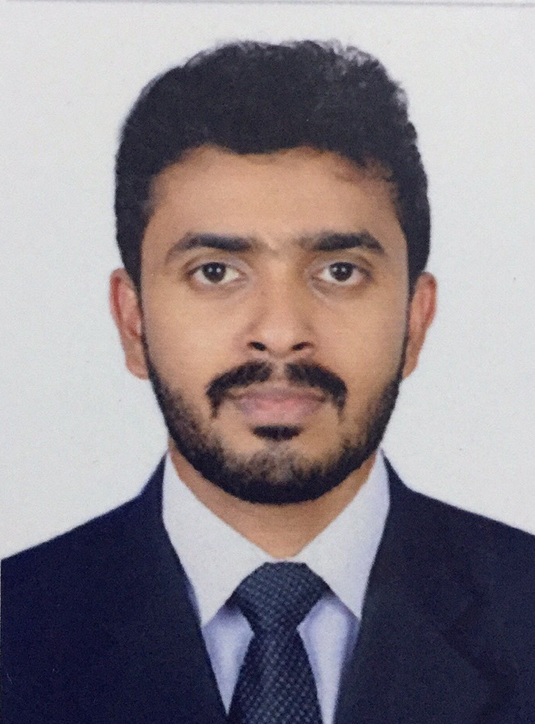
SARATH PRASAD P
Prasadam (H) Palattuvayalil
Chettikulam Elathur (PO)
Kozhikode 673303 Kerala India.
Mob : +91 6282351450
EMAIL ID : sharathprasad619@gmail.com

CAREER OBJECTIVE

To pursue a challenging career with dedication and provide my efficiency to the fullest in a professional organisational environment wherever I serve my duties that will discover the potential in me.

ACADEMICS:

- SSLC from CMC Boys High School, Elathur, Kozhikode (2007)
- Plus Two from GFHSS Puthiyappa, Kozhikode (2009)
- Diploma in Hotel Management from IITM-KILE, Westhill, Kozhikode (2011)
- Presently Doing B com with Co-operation
- STCW95 from Varuna Institute of Maritime Studies, Chennai (2019)
Security Trainy for Seafarers with Designated Security Duties.
Personal Survival Techniques.
Fire Prevention and Fire Fighting.
Elementary First Aid.
Personal Safety and Social Responsibilities.

PASSPORT DETAILS:

Passport No : U2217931
Date of Expiry : 27/11/2029
Indian CDC No : KOL120197
Date of Expiry : 25/12/2029
Indos No : 19ZN1250

LANGUAGES

- English
- Hindi
- Tamil
- Malayalam

EXPERIENCE

- 1 Year experience as a Senior Hotel Operation Trainee at THE ATRIA HOTEL, Bangalore.
- 1 Year experience as a Development Officer at Labour India Publications, Kozhikode.
- 1 Year experience as a Team Member at KFC Restaurant, Malappuram
- 2 Years experience as a Customer Service Associate at Western Group of International – Nesto Hypermarket, Ajman, UAE
- 1.3 Years experience as a Guest Service Associate at KEYS Selecet Hotel Malabar Gate, Kozhikode.

PERSONAL INFORMATION

Gender : Male

Father’s Name : Sathyan P

Religion : Hindu

Marital Status : Single

Nationality : Indian

Date of Birth : 17-06-1992

DECLARATION

I declare that the above furnished information's are true to the best of my knowledge. If I am given a Chance, I promise that I will do my duties to the entries satisfaction of my superiors and the best of my knowledge.

SARATH PRASAD P
Date :
Place

