**Curriculum vitae**

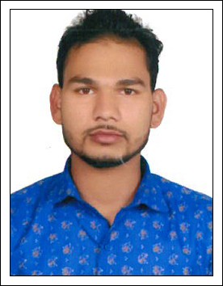

**NAME: MOHAMMED JAHIDUL ISLAM**

Mobile:+971 547673654

Email: islamjahed939@gmail.com

Visa: Own Visa

Dubai

Dubai – U.A.E

**­­**

**Welder ( arc &mig)**

**CAREER OBJECTIVES:**

A position with an organization where I can utilize the best of my skills and abilities that fit to my education. Skills and experienced a place where an encouraged and permitted to be an active participant as well vital contribute on development of the company.

# WORKING EXPERIENCES:

* I worked as a Welder& Gas Cutter In Al Hajiry Oil & Gas Co.LLC in Oman ( 7 years’ experience)

**DUTIES & RESPONSIBILITIES:**

* Fabrication of gates & rolling gates ,
* Hand rally &all kind of Fabrication
* Designed and built roof racks, bumpers, exhaust and various other accessories for off-road use.
* Performed Solid axle swaps on older generation Toyota vehicles.
* Performed transmission and engine swaps.
* Diagnosed repaired and maintained vehicles.
* Performed pre-welding layout design work and jig preparation, fabricated items, and selected the proper welding tools and material to complete projects.
* Ensured adequate welding supplies are ordered and available.
* Helped train, instruct, and assisted welders and other personnel.
* Performed other duties as assigned.
* Used rulers and templates to measure components for welding processes
* Assessed completed welding assembles per project specifications
* Tested welds for quality and tolerance
* Evaluated completed welds for flaws and cracks
* Organized and cleaned work area and welding equipment
* Assisted rigging table when needed

**Skills and competencies:**

* Strong ability to read and interpret engineering drawings and blueprints.
* Extensive knowledge of various welding techniques, including TIG welding, oxy-fuel welding, and arc welding.
* Excellent oral and **written communication skills**.
* Skilled in both mechanical and manual welding practices.

**COMPUTER INFORMATION:**

* Office packages : Microsoft Word, Excel, Outlook, PowerPoint
* Operating system : Windows 10 , XP

**PERSONAL INFORMATION:**

* Gender :Male
* Date of birth : 10-05-1990
* Marital status : Single
* Nationality : Bangladeshi
* Visa status : Visit Visa
* Language :English& Hindi

**PASSPORT DETAILS:**

* Passport No : BX0719675
* Place of Issue : DHAKA
* Date of Issue : 01-11-2018
* Date of Expiry: 31-11-2023

**EDUCATIONAL BACK GROUND:**

**High School**

**Declaration:**

I certify that the above are true and correct to the best of my knowledge and ability. If given an opportunity to serve you, I assure you that my wealth of knowledge will surely add value to your company and will satisfy my superiors.

**MOHAMMED JAHIDUL ISLAM**