**General Helper**

**Bright Okechukwu Osigwe**

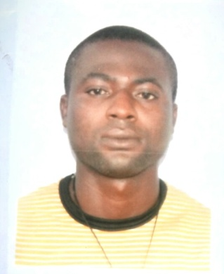Al baraha Building

Dubai, United Arab Emirates

Phone: +9715

Date of birth: 0525487583

Nationality: Nigerian

Visa Status: Visit visa

E-mail: okechukwub34@gmail.com

**Job Objective** To obtain the General Helper position within your company and provide excellent service.

**Highlights of Qualifications:**

* Hands-on experience in operating mechanical equipment’s
* Immense knowledge of various measuring instruments
* Excellent knowledge of repairing and maintaining locomotives
* Ability to communicate with clients on regular basis
* Ability to monitor several projects at one given time
* Ability to perform locomotive repair and maintenance

**Professional Experience:**

**GENERAL HELPER**

**Coleman Wires** 06/2016 – present

* Responsible for packaging sheeting and trimming materials
* Responsible for hemming and moving finished materials to loading trucks
* Commitment to safe work practices. DBCI has a culture committed to keeping our employees working safe and injury free
* Assist Machinists through cleaning of work areas/ milling machines/ equipment/ dies, etc
* Perform a variety of operations within group to maintain flow of work. Notify supervisor of unusual operating problems
* Follow safety rules and keep work area in a clean and orderly condition. Perform other related duties as assigned
* Performs general cleanup such as sweeping, removing various waste, cleaning shop and office areas, fixtures, equipment, washrooms and lunchrooms

General Helper  
Jim Beam Brands Co, Garden City, LEKKI  
August 2012 – 2016

**Responsibilities:**

* Performed routine duties and handled everyday material for effective operation of equipment’s.
* Administered various shop activities and provided assistance.
* Coordinated with bending machine operators for related activities.
* Participated in training programs for crane and loading operations.
* Provided assistance to shear operators and monitored shear products.
* Operated crave and removed unused steel bars in processes.

General Helper  
Per S Group, Inc, Garden City, Lagos  
May 2009 – July 2012

**Responsibilities:**

* Administered and provided assistance to everyday processes.
* Ensured optimal utilization of cleaning tools and agents.
* Monitored general activities of operations and provided assistance as per requirement.
* Operated light motor vehicle and ensured compliance to regulations.
* Maintained components and performed service on commercial service products.
* Facilitated lifting of heavy material with help of crane.

**EDUCATION**

* Certificate of Senior Secondary School Certificate

**LANGUAGE**

English Fluent.

**REFEREES: Available on request**

**DECLEARATION:** I certify that the above are true and correct to the best of my knowledge and ability.