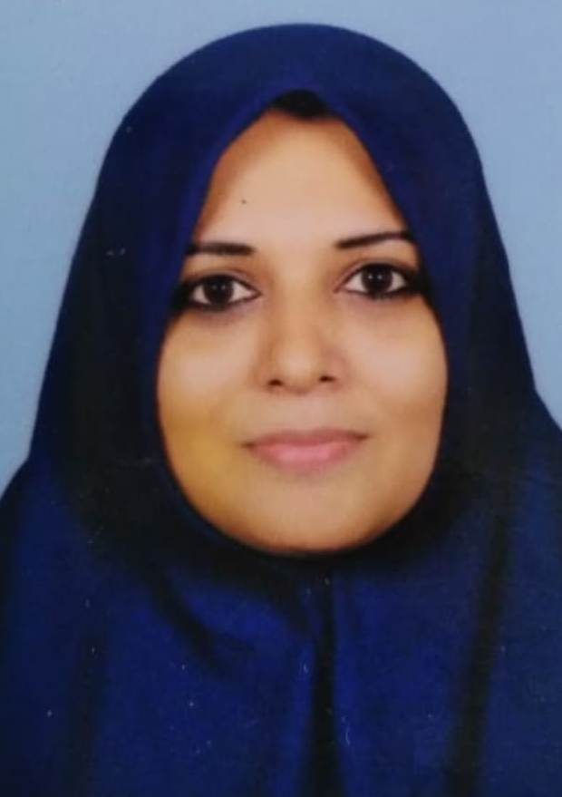

**Name** : KHAMARBHANU. T

**Email**: kamarbanu462@gmail.com

**Phone Number** : 9496666462

**Date of Birth**: 08.11.1976

**Address:**

Thottoli House

Kilthan Islan

Lakshadweep

Pin:682558

**Career Objective:**

I plan to build a long term career with a progressive and professionally managed institution in a competitive, challenging and rewarding environment. I have equipped myself conceptually and practically towards achieving my goal and on the look out for an opportunity to apply myself. Excellent organizational skills with superior memory for details and a strong work ethic.

**Educational Qualification:**

* BA English Literature
* MA English Literature
* B Ed English
* CTET

**Experience:**

15 years experience in teaching field.

**Languages Known:**

* Speak : English, Malayalam, Hindi, Mahal, Jasari
* Read & Write : English, Malayalam, Hindi, Arabic

**Personal strength:**

* Responsible and Reliable
* Communication Skill
* Self-Motivated and Hard working

**RESUME**

**Extra Skills**

* Diploma in Counseling

**Declaration**

I am confident that I shall strive and succeed in the position applied to the satisfaction of my superiors and justice the assignment entrusted on me.

Place: Mavoor Yours sincerely,

Date: