CURRICULUM VITAE  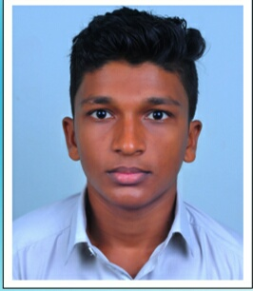  Mr. SHAHABAS A  Address:  Nayikkottakkal (H),  Kannamvettikavu(P.O)  Pulikkal  Malappuram Dist.  Kerala, 673637  Contact Information  Mob:+91 9847572531  Email:  Ashahabas240@gmail.com  Personal Details  D.O.B: ^{28/11/1999}  Sex : Male  Marital Status: Single  Nationality: Indian  Religion: muslim  Languages Known: English, Malayalam  Hobbies  Travelling, Driving, Playing | CAREER OBJECTIVE  Looking forward to be a part of an organization where I can best utilize my skills in the best interest of the organization, and thereby together achieve personal as well as organizational goals.  CURRENT QUALIFICATION  ITI in Electroncs Mechanic  EDUCATIONAL QUALIFICATION  Course Institute Board/University  ITI HMO PVT ITI MANJERI NCVT  SSLC AMMHS PULIKKAL Kerala Public Examination Board  PLUS TWO NNMHS CHELEMBRA Kerala Public Examination Board  TECHNICAL SKILLS  - SOLDERING  - COMPUTER HARDWARE

STRENGTH
- Leadership Quality
- Capacity to work efficiently in a team
- Positive attitude
- Ability to Rapidly Build Relationship and Set up Trust

DECLARATION
I hereby solemnly declare that the above information is true to the best of my knowledge and belief.

Date:28-05-2019 SHAHABAS A

