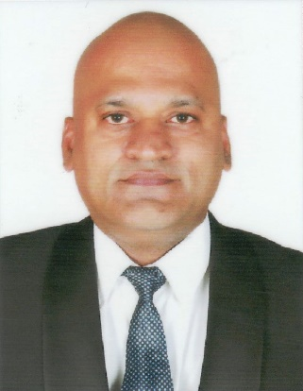

Ritesh John Dsouza

Nationality: Indian Passport No: W3203738

Mobile No:- +00971559176328 / 0504897566

Email id:- [ryan_bradely@yahoo.com](mailto:ryan_bradely@yahoo.com)

Visa Status: Visit Visa 3 Months

Dubai Address:- Al Majid Bldg

Al Rigga 43 Street

Dubai Flat No 216 02nd Floor

Objective:I can work independently using my own initiative or as part of a team.

Skills and Strengths:

Skills: good communication, concentration and focus that has made me a team player decisive and spontaneous in my decisions at my current operations control, enabling me to work independently.

* Active Listening.
* Determination honesty resilience.
* Communication.
* Customer Service.
* Interpersonal skills.
* Leadership.
* Positive attitude and strong work ethic.
* Problem-Solving.
* Ability to Work under Pressure.
* Decision Making.
* Time Management.
* Self-motivation.
* Confidence and team player.

Education:

|  |  |  |
| --- | --- | --- |
| **Course** | **Institute / University** | **Year** |
| T.Y.B.A | Bundelkhand University Jhansi | 1999 |
| H.S.C | Delhi Board | 1995 |
| S.S.C | Delhi Board | 1992 |

Work Experience:

Vara Infotech Pvt. Ltd. / Wipro [26th December 2017 till 30th Septemer2019)

(Working with ICICI Bank on behalf of Wipro Ltd.)

Designation: Senior Executive

From 01st of October 2019 Wipro took Over Vara Infotech Pvt Ltd. till 01st of October 2022) I worked with Wipro till 01st of October 2022. This was my Last Working day With Wipro.

Job Profile

.

* Handling Cash Withdrawals and Cash Deposits Pan India for Our Cooperate Client that is Standard Chartered Bank.
* Preparing MIS Repots of Cash Withdrawals and Cash Deposits on a Daily Basis.
* Coordination with DBM and Branch Managers of ICICI Bank Pan India regarding Denominations as well.
* Doing Pass Book Entry for our Walk In Customers in Our Bank.
* Getting FD for ICICI Bank and even achieving the monthly Target as well.

Bank of America [16th February 2010- 2nd January 2013]

Designation: Collection Officer

My duties : Calling up Customers and Ensuring to Recover the Money regarding their libalities, for their loans sending Emails to Customers, doing Field Visits and Ensuring that to have a Smooth Collection and to meet our Collection Target.( Was Doing Collections in Buckets. ) I Can also handly Recoveries.

Raj Enterprises [2nd January 2000 - 25th October 2008]

Interacting with Wholesalers & Clients Regarding the Products

Designation: Sales Coordinator cum Office Assistant

Job Profile

Drafting Letters in Ms-Office Word Sheet, Preparing Quotation for Clients, Worked on ERP Software.

Computer Skills

* Ms-Office (Word, Excel, PowerPoint)

Extra-Curricular Activities

* Member of Youth Group in Malad
* Member of the Foot Ball and Hockey Team in Malad

References

Mrs. Rita Jean Dsouza – St. Anthony School as a Secondary Teacher

Mobile No: - **9833767769**

Would like to extend my services to the company learn, teach, and work in togetherness that is what a successful business requires.

RITESH JOHN DSOUZA