RESUME

DEENA KOMMADATH  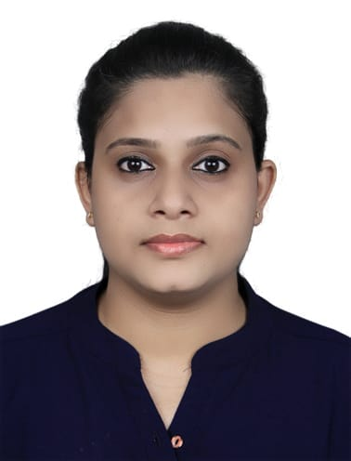  Email:  Deenarajan6@gmail.com  Contact. No.:  +971526122534  +971526906265  Present Address  Flat No 214  Fourth block  SKN building  Industrial area 11  Sharjah  UAE  Visa status: Visiting  Expiry : 10 Feb 2021  Personal Details  Date of Birth:02/03/1987  Sex : Female  Nationality :Indian  Religion : Hindu  Marital Status : Single  Passport No : U4083789  Expiry :18 Mar 2030  Hobbies  - Hearing Music  Languages Known  To read write:  English & Malayalam  To speak :  English, Hindi, Tamil,& Malayalam | Objective  Highly self-motivated individual seeking an opportunity to apply for Challenging and rewarding positions in the any industry in which I can be a major contributor, enhance my skills, and broaden my areas of expertise with utmost sincerity & hard work to fulfill individual & organizational goals and contribute something of lasting value that will benefit the society.  Description  - Good Team player.  - Dedicated to maintain high quality standards and timeliness.  - Good Motivator.  - Good Communication Skills  - Good Interpersonal Skills  - Good Management Skills  - Good in Event Organizing  - Friendly Movement with Others  - Sincerity in Work  Work Experience  - 08 years experience as Senior Executive-Customer Service in Indigo Airlines at CCJ Airport, Calicut, Kerala.  - Worked as Trainee Assistant Supervisor Grade III in IGI Airport Terminal 3,New Delhi under CAMBATA Aviation, handling of AIRFRANCE from Jan 2011 to March 2012.  - Worked as Customer Service Agent (Trainee) in Mumbai International Airport under GVK by the guidance of Airawat aviation for 4 months.  Nature Of Work In Indigo Airlines  - Handling office administration and finance  - Responsible for documentation check of passengers (International/domestic)  - Load and Trim: Aircraft weight and Balance (Airbus320/321/ATR)  - Ensuring Customer queries/complaints should be resolved timely and efficient manner.  - Handling counter supervision, floor management and allocation planning  - Handling boarding gate function  - Handling Miss handled Baggage (MHB)  Education  - MBA in Airline and Airport Management fr0m Alagappa University(2011)  - Bachelor of Commerce (graduation) completed at Don Bosco College.(2009)  - Completed X11th from Jayasree Higher Secondary School.(2006)  - Completed Xth from St Joseph English Higher Secondary School(2004)  Technical Skills  - Departure Control System  - LOAD and TRIM  - MS Office ,Excel  - Tally, Computerized accounting  TRAINING  - LOAD AND TRIM  - Departure Control System (DCS)  - Advance Departure Control System (Advance DCS)  - Ignite Zeal/ Ignite Zeal Plus  - Service from the heart (SFTH)  - Ramp Safety Training  - Dangerous Good Regulation Training(DGR)

Declaration

I hereby declare that the information furnished above is true to the best of my knowledge.

Place: Sharjah

Deena Kommadath

