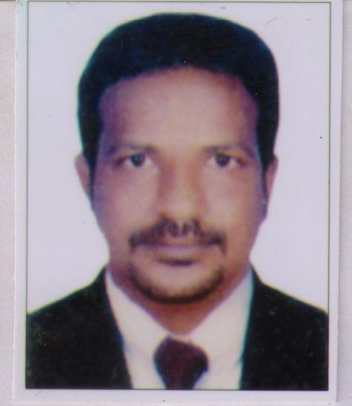

BYIJU EAPEN
VILLA NO.05
BEHIND SOHAR SCHOOL
RAS AL KAIMA, UAE
Ph. +971 521792376
e-mail :byju.anakalil@gmail.com

Objectives – To seek a challenging and rewarding career in an organization this provides avenues for continuous growth utilizing my creativity and zeal to learn.

STRENGTHS :-

- Self confident, self-disciplined, & diligent person.
- Human Relation attitude, leadership & foresight skills.
- Honesty & positive thinker with optimistic & practical approach towards problems.
Key skills

Develop safety working teams, conduct safety meeting, training to workers, organize fire department , organize periodic testing maintenance of fixed fire fighting equipments and its record keeping

PERSONAL INFORMATION:

Father’s Name : Mr. K M Eapen
Date of birth : 09/05/1979
Nationality : Indian
Religion : Christian
Communication Address : Byju Eapen
Podippara Anackallil
Velliyara P.O. , Pathanamthitta(Dist)
Kerala-689612, South India
Ph: +91-8590608334

Visa Status : Visit visa

ACADEMIC QUALIFICATION
School/College | Board/University | Year of Passing
SSLC | Board of Public  Examination, Kerala | 1995
Pree- Degree | M G University | 1997
Bcom | Mahatmagandhi University | Not completed

Professional qualification
Course | Institution | Year of Passing
Diploma in fire and safety | NIFE pathanamthitta | 2009
IOSH | DIS,QATAR | 2013
NEBOSH | DIS,QATAR | 2016
OSHA 30Hr | www.360training.com | 2020
Computer operating and programming assistant | St.johns ITC Mallapally | 1999

WORK EXPERIENCE

Year | Company | designation
2004 to 2007 | Icici bank commercial business | Finance executive
2009 to 2013 | Ushus engineering | Safety supervisor
2013 to 2016 | G4s Qatar | Fire warden
2017 to 2020 | Toa corporation Kuwait | Safety indicator

HOBBIES
- Listening music.
- Reading magazines & journals.
- Sports & Games.
LANGUAGE PROFICIENCY

- English, Malayalam and Hindi.

PASSPORT DETAILS

PASSPORT NO : P1804772
DATE OF ISSUE : 16/12/2016
DATE OF EXPIRY : 15/12/2026
PLACE OF ISSUE : TRIVANDRUM

DECLARATION
I hereby declare that all the information furnished above is true to the best of my knowledge.

Place : Ranny
BYIJU EAPEN

