**HEMANTH GANESH**

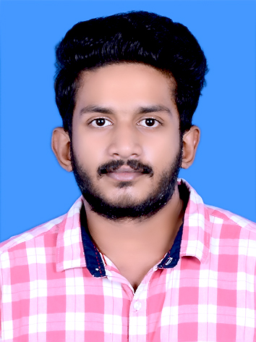

**CHOLAYIL THODIKAYIL,**

**MOKKAM P.O, CALICUT,**

**KERALA, PIN : 673602.**

**Email:hemanthganesh78@gmail.com**

**Mobile: +91 9447586276**

**CAREER OBJECTIVE:**

To work for an organization which provides me the opportunity to improve my skills and knowledge to growth along with the organization **objective**. An enthusiastic **fresher** with highly motivated and leadership skills having bachelors of engineering degree in Civil Engineering.

**BASIC ACADEMIC CREDENTIAL:**

|  |  |  |  |
| --- | --- | --- | --- |
| **Qualification** | **Institution/(Board/University)** | **Year** | **Percentage** |
| **B.E Civil Engineering** | Mahendra Engineering College(Autonomous)  (Mahendirapuri, Namakkal) | 2015-2019 | CGPA:7.14 |
| **PLUS 2 (VHSE AGRICULTURE)** | REC GVHSS,Chathamangalam (NIT,Calicut) | 2015 | 69% |
| **SSLC** | FMHSS Koombara (Thiruvambadi,Calicut) | 2013 | 80% |

**INDUSTRIAL TRAINING AND VISITS:**

* Undergone five days In-plant training at “Melaka University”, Malaysia.
* Undergone five days In-plant training at “Tata reality and infrastructure limited”, Kochi.
* Undergone five days In-plant training at “Silent Creek Construction limited”, Kozhikode.

**CERTIFICATIONS:**

* Participated in “Intelligent Machine Automation”, Multimedia University(MMU), Malaysia.
* Participated in “Characterization Of Cement Concrete” Mahendra Engineering College, Namakkal.
* Participated in “Precast Construction And Practices” Mahendra Engineering College, Namakkal.
* Participated in “Building Information Modeling”, CADD Centre Thiruchengode, Salem.
* Secured 1st place in “Model Making” in Intra Department Technical Competition, Mahendra Engineering College, Namakkal.

**TECHNICAL SKILLS:**

* AutoCAD

**INTERPERSONAL SKILLS:**

* Adaptable
* Confident
* Time management
* Hard working

**PROFESSIONAL AFFILIATIONS:**

* Student member of Indian Concrete Institute (ICI).
* Student member of Junior Red Cross Society (JRC)
* Volunteer in a National Level Technical Symposium ”Ciraz 16”.

**LANGUAGE KNOWN**

* English.
* Malayalam.
* Hindi.
* Tamil.

**PERSONAL DETAILS:**

**Father’ Name :** Ganeshan C.T

**Date of Birth :** 2nd April 1997

**Language Known :** English, Malayalam, Hindi & Tamil

**Nationality/Religion :** Indian / Hindu

**DECLARATION:**

I do hereby declare that the information furnished above is true to the best of my knowledge and if selected I would apply my sincere effort for the welfare of organization**.**

Place: Calicut [Hemanth Ganesh]

Date : 16/01/2020