MOHAIDEEN JAHIR HUSSAIN

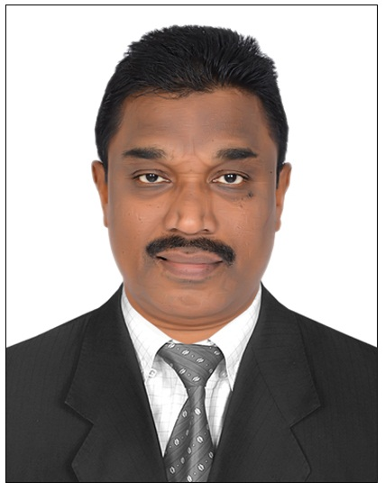

Dubai, United Arab Emirates

Mobile. 050-948 41 27

E-Mail: jahirmcom@gmail.com

PERSOANL PROFILE:

I am a very practical person who enjoys working in a hands on capacity. I have done driving
Work for many years and I enjoy meeting different people, seeing different places in a work
capacity.

I have got excellent communication skills and a good sense of my local area. I travel quite
frequently and feel to have a good sense of direction and be able to find my way to places
quite easily with and without map.

I can plan my time well and always ensure that I allow for traffic and road works when I am
planning my routes. I am self motivated and enthusiastic in my work and enjoy working hard.

EMPLOYMENT HISTROY

BELSELAH GROUP, DUBAI APRIL 2013 TO NOVEMBER 2019

My Responsibilities Include:

- Organizing my schedule of for driving.
- Dealing with any payments from Clients.
- Communicating well with clients.
- Collecting clients from airports, meeting establishments, restaurants etc.,
- Planning routes researching traffic and road works to ensure less delay.
- Over my vehicle and ensuring that is clean inside and out.
- Bank work assist with Finance department.
- Collecting Invoices and Chceques.

HASSAN ESTABLISHMENT JULY 2009 TO JANUARY 2013
KINGDOM OF SAUDI ARABIA, DAMMAM

- Handle mail and good receiving including arranging local and overseas courier.
- Perform outdoor assignment such as documents collection and delivery.
- Perform all bank transactions-when required.
- Check and refill paper supplies and toner for copiers.
- Handle pantry replenishment.(order supplies, refilled bottle water etc.,).
- Good communication Skills-Must be able to good read and write in English.
- Carryout minor repair/fix in the office.
- Willing to work weekends and after work hours-when required.

Professional Training February 2003 to June 2005

Worked as a “Driver” in SRACO, Dammam, Saudi Arabia. During this period,

Responsibilities Include.

- .Planning and directing routes to ensure the safe and secure delivery of customer.
- Bank work Assist with Accounts Department.
- Scheduled delivery time , Presenting Invoices Collecting Payment.
- Obtaining Customer Signatures on delivery documentation.
- Performing Vehicle inspections inclusive of water, Oil, Tyre, and mechanical problems.

Academic Qualification

- B.Com.., 1983-1987 Madurai Kamaraj University , Madurai, India

SKILLS AND ABILITIES

Well versed with the latest versions of MS Windows, MS Internet Explorer, MS Excel, MS Word & MS Power Point.
Valid U A E Driving License.
HOBBIES AND INTERESTS:
Reading Books, Playing Cricket, Swimming.

Personal Profile

- Nationality India
- Date of Birth 03/05/1967
- Religion Islam
- Marital Status Married
- Passport Number J 5955769
- Visa Status Visit Visa (Valid until 19/11/2020)

References

Will be furnished on demand

