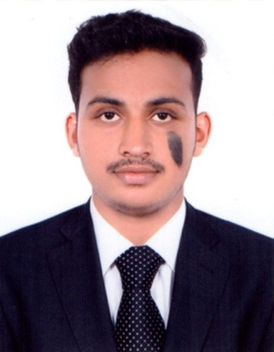

**SONU VARGHESE**

**abudabi , UAE**

**Mobile: +971547217507**

**Email: sonuvarghese0007@gmail.com**

A dynamic professional with nearly 4 Year of rich expertise in cash receive payments& Accounts.

**OBJECTIVE**

To work for an organization that gives scope to update my knowledge and skills in accordance to the latest trends and be a part of the team that dynamically work towards growth of the organization and gain satisfaction thereof.

## SUMMARY

* Bachelor of commerce (Computerized Accounting) with nearly **4 Year** of experience in **Accounts & finance**.
* Skills in **ERP Packages** of **SAP Business One, FI/CO, Tally 9.0, Peachtree, Quick Books.**
* Proficient with computer skills and comfortable with **MS office packages, Excel**, **Internet and Emails.**
* Demonstrated abilities to **co-ordinate** the efforts of a large team of diverse employees.
* Efficient in generating **Daily reports and record upkeep**.
* Exceptional ability to quickly master new concepts, earning of new strategies as well as capable of working in-group & independently with excellent communication skills.
* High level of Personal integrity and workplace ethics.

# WORK EXPERIENCE :

|  |
| --- |
| **WORKED AS A ACCOUNTANT IN JUMASAESSA TRADING FOR 2 YEAR (DUBAI,UAE)**  **WORKED AS ACCOUNT ASSISTANT IN NEFMS GENERAL TRADING 1 YEAR (DUBAI)** |

**Accountants Service Society Period in 1 Year**

**Designation: Accountant**

**Responsibilities:**

* Handling monthly journal entries, Accounts and various ledgers.
* Managing monthly sales and marketing expenses.
* Preparation of balance sheets.
* Preparation of final accounts – computerization of accounts of almost all types of business organization using Tally9.0, Peachtree, quick book.
* Preparation of various accounting reports like Ratio analysis, Income & Expenditure statements, Bank Reconciliation statement etc.
* Preparation and filling of Vat Return
* Preparation of Cash Book – Purchase Day Book – Sales Day Book – Purchase Return Book – Sales Return Book – And other Subsidiary Books.
* Preparation of Purchase Register – Sales Register – Cheque Receivable Register – Cheque Payable Register
* Writing up of book and finalization of accounts of Trading, Manufacturing, Service and Nonprofit Organization

**Skills**

* Organization.
* Time management.
* Adaptability.
* Communication.
* Opennes.
* Leadershi.

**ACADEMICS**

|  |  |  |  |
| --- | --- | --- | --- |
| NO | COURSE | BOARD/ UNIVERSITY | YEAR OF PASSING |
| 1 | SSLC | BOARD OF KERALA | 2009-2010 |
| 2 | PLUS TWO | HIGHER SECONDARY BOARD OF KERALA | 2010-2012 |
| 3 | DCAM | ACCOUNTANTS SERVICE SOCITY | 2014 |
| 4 | DEGREE B COM | Dr.CV RAMAN UNIVERCITY | 2015 |

**PERSONAL DETAILS**

Date of Birth : 07-09-1993

Marital status : Single

Languages : English, Hindi, Tamil & Malayalam

Nationality : Indian

Visa Status : Visit Visa

**DECLARATION**

I solemnly declare that the above furnished details are correct and true to the best of my knowledge.

**Place: ABUDABI**

**Date :**  **Sonu Varghese**