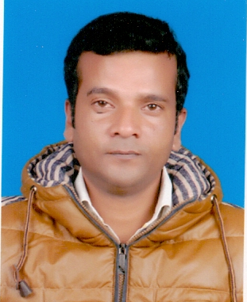 | Javed Ali  37, Male, Indian  Bazar Salabat Khan, Jamund.  Bhadohi-221401 U.P. India.  0091-9151696131              shamsali611@gmai.com

Statement of Objectives

- To be associated with a progressive organization which can provide me with a dynamic work sphere to extract my inherent skills as a Professional, use and develop my aptitude to further the organization’s objectives and also attain my career targets in the progress.

Working Experience

- Position of Responsibility:
Machine Operator

- Work with Carpet Industry Co. K.S.C. www.carpetskuwait.com Sabhan Industrial Area P.O. Box: 929 Hawalli Manufacturer and exporter of different types of Carpets Like Hand Tufted, Machine made carpets and Textiles Product etc.

- Spinning section as a Twisting Machine Operator .
- Maintain Quality Level within the specified client AQL Level
- Maintains management guidelines procedures.
- Prepare production reports on time accurately.
- Since 26th January 2016 to 31st October, 2016.

- Position of Responsibility:
Machine Operator

- Work with Carpet Industry Co. K.S.C. www.carpetskuwait.com Sabhan Industrial Area P.O. Box: 929 Hawalli Manufacturer and exporter of different types of Carpets Like Hand Tufted, Machine made carpets and Textiles Product etc.

- Boiler Operator (Yark Shipley, Cochran, Atlas & Bono Boiler)
- Maintains management guidelines procedures.

- Since 26th January, 2016 to 31st January, 2018

- Position of Responsibility:
Laundry man

Work with Laundry company in Gujrat India as a automatic steam Laundry press man in clothes and handling customer service.

- Since 03-March, 2018 to January-2020

Educational qualification

- Academic Qualification:
10+2 under C.A.B. College Allahabad Affiliated with U.P Board in 1999
10th under M. A. S Inter College Bhadohi Affiliated with U.P. Board in 1997.

Technical Skills

Computer basic fundamental, Dos, Win- Xp, Ms. Office, Concept of Multimedia etc.

Summary of skills

- Strategic Business, Good Communication, Broad Management, Motivation Factor, Disciplinary Personality.

Personal Details

Father’s Name | Mr. Akbar Ali
Occupation | Business
Mother’s Name | Mrs. Bilquish Jahan
Occupation | House wife
Date Of Birth | 21 May-1981
Place Of Birth | Bhadohi (U.P.)
Marital status | Married
Nationality | Indian
Religion | Islam
Passport Number | N4087710

- Language Proficiency:
Language | Speaking | Reading | Writing
English
Hindi
Urdu
Arabic

Other Information

- Hobbies- Listening religious preachers and authentic books of religions and watching movies in pastime.
- Strengths- Effort oriented approach in life rather than goal oriented,
- Weaknesses- Emotional sensitivity for certain social issues.

Declaration

I hereby declare that the information stated above is true to the best of my knowledge. In case of an opportunity, I shall by rules and regulation of my host organization and be sincere, dedicated and punctual towards carrying out my duties.

(Javed Ali)

Date :- 07-July-2022

